Libellula Creations (LibellulaCreations.com) an Upscale Baby Boutique, announces their Big Sale on Big, Brand Name Labels.
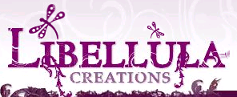

Released on = May 29, 2007, 2:24 pm
Press Release Author = Rhonda Smith/Owner
Industry = Apparel & Fashion
Press Release Summary = These labels include:
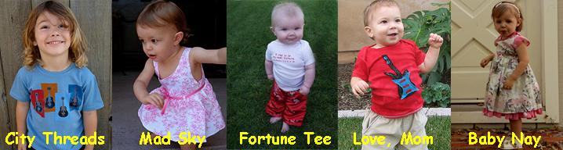
These big, brand labels are marked down 15% to 25%.
Press Release Body = Libellula Creations is also proud to offer a diverse line of apparel and accessories which include:
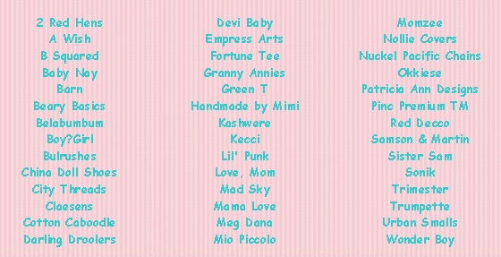
Libellula Creations is a privately held, California based on-line baby boutique. Their goal is to specialize in hip/urban infant, toddler, and maternity clothing as well as accessories. They personally hand pick all of our products and take pride in bringing them to their customers. Sizes range from 0 to 6x.
Products include but are not limited to diaper bags, hooded towels, wash mits, children’s footwear, baby blankets, stroller blankets, boys and girls clothing, tutu’s, and various accessories.
***The Spring line has arrived!!!!!****
For more information on about Libellula Creations, please visit their website at http://www.LibellulaCreations.com
###
Web Site = http://www.libellulacreations.com
Contact Details = Our contact information is as follows:
Libellula Creations
16787 Beach Blvd., Suite 653
Huntington Beach, CA 92647
(714) 846-1081
(888) 545-3724

