Libellula Creations (LibellulaCreations.com) is now announcing its bold Spring/Summer line. This hip, chic online boutique is now authorized to sell Baby Nay and Wonder Boy
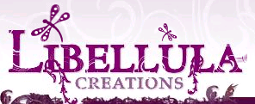

Released on = May 4, 2007, 4:09 pm
Press Release Author = Rhonda Smith/Owner
Industry = Apparel & Fashion
Press Release Summary = The owners of Libellula Creations have taken great pains to bring their customers quality, upscale infant and toddler clothing that is edgy and will stand up to your childs lifestyle. You will find only the best brand names and quality clothing with manufacturers such as City Threads, Mad Sky, Trumpette, Barn, and many more of the apparel industries best and brightest.
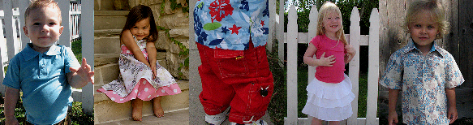
Press Release Body = This brings us to Libellula Creations philosophy. It is simply respect. Libellula's customers will find that respect goes hand and hand with customer service and their customers will definitely be treated like one of the family.
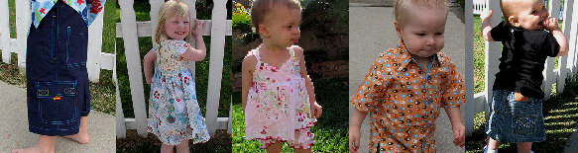
Libellula Creations motto is “Let your little Libellula fly in style.” This won't be difficult with all of the upscale, hip lines they have to offer.
Libellula Creations is also proud to announce that the sizes they offer now range from 0 to 6X.
Please visit us often!
Web Site = http://www.libellulacreations.com
Contact Details = For more information about Libellula Creations, please visit their website at http://www.libellulacreations.com
Contact information is as follows:
Libellula Creations
16787 Beach Blvd., Suite 653
Huntington Beach, CA 92647
(714) 846-1081
(888) 545-3724

