New Book Pits Fictional Detective against Real Crime—Identity Theft


Released on = May 15, 2007, 6:43 am
Press Release Author = Bast Press
Industry = Advertising
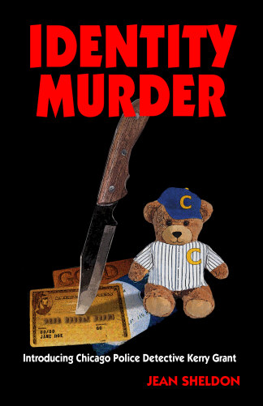
Press Release Summary =Identity theft is the fastest growing crime in the US. In her book 'Identity Murder', Jean Sheldon introduces fictional crime fighter, Chicago Police Detective Kerry Grant who chases computer criminals through cyber space as well as the streets of Chicago.
Press Release Body = Albuquerque, NM. (May 2007) The increase in online crime has police nationwide preparing for a twenty-first century show down.
Kerry takes her expertise undercover with the mob. She teaches eager cyber thugs the latest tricks and scams while checking out their involvement in online crime. When they catch her hacking into their system, she realizes she taught them one trick too many. As she reaches for her weapon, Kerry faces the barrel end of a gun in the hand of a man she doesn’t want to love.
The detective starts a romantic relationship, renews a friendship, and deals with her own demons, while she continues to chase virtual criminals firing real bullets.
You can find more information about Identity Murder and Detective Grant at www.bastpress.com. 'Identity Murder' by Jean Sheldon, Trade paperback, $14.95.
# # #
Web Site = http://www.bastpress.com
Contact Details = Bast Press
JA Slashinski
PO Box 3965
Albuquerque, NM 87190
ja@isp01.net

