Student jetPacks



Released on = May 26, 2007, 10:19 am
Press Release Author = Joe Cawley
Industry = Internet & Online
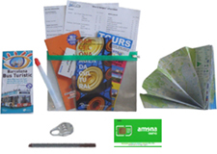
Press Release Summary = A new UK company has taken the worry out of being prepared with the ultimate travel accessory, giving young travellers a head start on their journey.
Press Release Body = Savvy travelers fly with a Student jetPack
A new UK company has taken the worry out of being prepared with the ultimate travel accessory, giving young travellers a head start on their journey.
Traveling is an eye-opening experience, but one fraught with difficulties if not enough planning is involved.
Student jetPacks aims to increase the safety and experience of youth and student travelers, by providing essential information and vital products prior to departure.
Equipped with a local SIM card, travelcard, coinage, maps and city information, a Travel jetPack will help travelers get organised and save money on their travels!
All jetPacks are country specific, including the UK, Spain, Australia, Austria, Germany, New Zealand, and Poland.
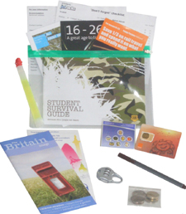
As an example, a UK jetPack contains the following:
• A pre-activated pre-pay UK SIM card with £1 credit
• £2 International dialling card
• The Britain Big Map (2 x 3 ft) highlighting all cities and major towns as well as the road and rail networks. The map also contains a guide to Britain's 120 top attractions.
• London bus and tube attraction map
• Rail and Coach discount information
• Student info pack
• £1.50 emergency loose coin bag
• Luggage lock
• Property security marker
• Emergency light stick
• A 'Don't Forget' checklist for before, during and after your visit.
• Emergency contact/info card
• jetPack document/passport holder
Priced at around $50, a Student jetPack could be a lifesaver for new arrivals, AND ease the worries of concerned parents at home.
See www.studentjetpacks.com
FREE OFFER: Quote reference JO73 and also get a 150-word pocket phrase card free with every Travel jetPack, or a luggage lock free with every travel accessory.
Web Site = http://www.studentjetpacks.com/?utm_source
Contact Details = Contact writer@joecawley.co.uk
+34 922 857002

