Boot Camp downtown Calgary opens up and gets fitness into high gear.
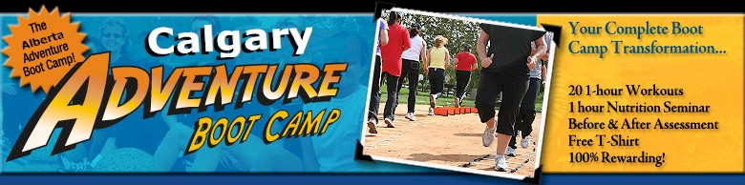

Released on = June 13, 2007, 6:37 am
Press Release Author = Allan Fine
Industry = Healthcare
Press Release Summary = Physical education instructor Allan Fine pumps some iron in Downtown Calgary's Prince's Island Park. He has been teaching Adventure Boot Camp since June 2007. Though the early drizzle in Calgary, several dozen women came to strength train at 5:30 a.m. and 12 noon.
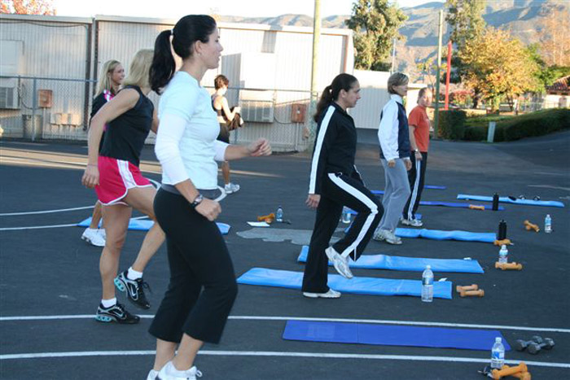
Press Release Body = Calgary-Boot Camp downtown Calgary opens up
Price: Please contact
Title: Boot Camp downtown Calgary opens up and gets fitness into high gear.
By Allan Fine Released
Summary: Physical education instructor Allan Fine pumps some iron in Downtown Calgary's Prince's Island Park. He has been teaching Adventure Boot Camp since June 2007. Website: http://www.albertabootcamp.com/
Boot Camp downtown Calgary opens up and gets fitness into high gear.
Physical education instructor Allan Fine pumps some iron in Downtown Calgary's Prince's Island Park. He has been teaching Adventure Boot Camp since June 2007. Though the early drizzle in Calgary, several dozen women came to strength train at 5:30 a.m. and now 12 noon Downtown It can get up to 35 degrees outside, wet or sun — but more than 35 women and men gathered in Bowness and at Prince's Island Park to challenge themselves with a rigorous work out called Adventure Boot Camp.
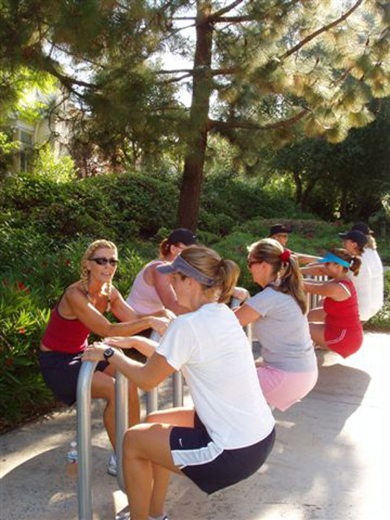
People join the at-your-own-pace group program for a number of reason. Those who stick with it, however, all have the same reaction of love to the outdoor get-fit program that utilizes teamwork for four-week sessions. Adventure Boot Camp began with fitness nut Allan Fine and his Dream. While taking his Masters in Lifecoaching, he discovered Adventure Boot camp. Allan wanted to start a new business in Calgary and the boot camp trend was becoming popular. He decided to find a boot camp name without the military theme to keep the concept recognizable.
His idea became a reality in Jan 2007 when he graduaated from ABC and in April 2007 his first boot camp opened in Calgary. Now classes are opening all over the Calgary area.
His co-ed boot camps offered at various times Monday through Friday offered as four-week programs meeting three or five times per week. Campers are exposed to a four week on, one week off schedule to not overload the muscles. The off week gives trainers the chance to meet with campers who completed a camp and new campers about to embark.
Everyone who signs up has a 30-minute consultation the week before camp, said Allan. This time is set aside to explain how the program works, what to bring, review the camper’s medical history and gives the coaches a chance to know who the campers are and what they’re hoping to gain.
“We want to give guidance before they start to program so they can get the most out of it. Their goal needs to be in perspective. Many times when people start they don’t have a plan. They just think weight loss and for some people that might be the case. Others might just feel lazy. They feel like they need to do this for some reason.
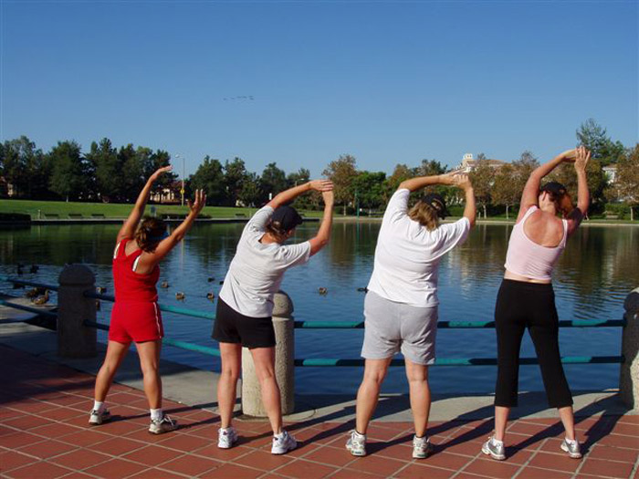
We want to give them something measurable but realistic. ... If they don’t have a realistic goal they could be disappointed about how things turn out,” she said.
Boot camp isn’t someone yelling in your face. In fact, the coaches act to encourage and keep things moving. After warming up, participants get to choose which difficulty level works for them. The group is split in half. On Monday, the lower difficulty level people began with cardio-based training including endless lunges, jumping over 1-foot hurdles, jogging and jumping jacks. Each activity had a follow-up, keeping everyone moving at their own pace. No one is waiting for someone else to finish or feeling pressure because they’re the last one attempting an activity. In that sense, the class works like a circuit exercise focusing on keeping up the heart rate.
Many campers sign up for 3 or 4 camps in a row with a discount.
What campers have to Say:
“The first two weeks were hard. It’s a little difficult for the new people. It’s pretty strenuous exercise. I knew because my sister-in-law told me so. ... I had to be willing to work at my own pace. The coaches help you at that. I was one of the last people coming in after a jog,” Judy Shaw
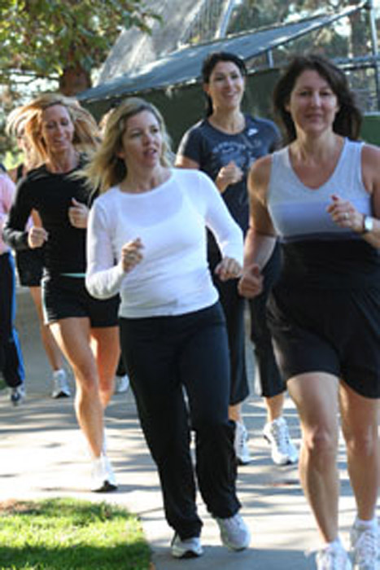
“Once I got over that, halfway through the second week. If I go at [other people’s] pace I’m going to be injured and I’m not injured at all. If I’m behind I’ll be fine. I’m just going to keep doing what I can do and try to progress each time,” she said.
When the groups switch there is light weight training exercises waiting. Women roll out yoga mats and grab free weights at the weight of their choice and begin various lunges, jumping exercises and lifts that work the back, chest and arms. Again, everyone goes at her own pace integrating jumping and small cardio breaks in between the weight work.
“It’s hard and definitely challenging. I loved it. I knew I would. [When I started] I would jump out of bed,” said Shaw
Campers want a structured environment in which they dont need to think about what to do next that offered a great workout. That’s why boot camp keeps calling campers back.
For more information visit http://albertabootcamp.com/
What do you think of this story?
Web Site = http://www.albertabootcamp.com/
Contact Details = Allan Find can be reached by e-mail: support@albertabootcamp.com
or by phone: (403) 246-7386 ext. 3.

