Cosmetic Dentistry Zooms in on Whiter, Brighter Smiles
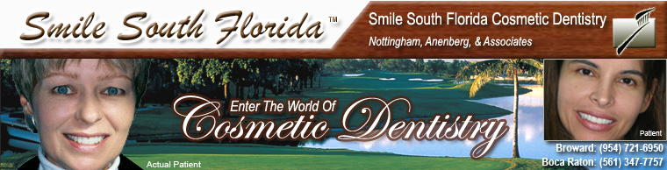

Released on = July 12, 2007, 5:18 pm
Press Release Author = Smile South Florida Cosmetic Dentistry
Industry = Healthcare
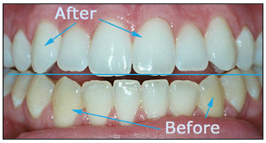
Press Release Summary = Whiter teeth aren’t just for extreme makeovers. The Zoom!® whitening procedure is a popular method among cosmetic dentists who seek to give patients bright, beautiful smiles.
Press Release Body = July 10, 2007—MIAMI, BOCA RATON AND FORT LAUDERDALE, FLORIDA— Smile South Florida Cosmetic Dentistry has a new way of helping patients achieve a beautiful white and bright smile in just 45 minutes.
This method of making smiles as bright as the Florida sun is called the Zoom!® whitening procedure, and it is one of the most popular teeth whitening procedures used by cosmetic dentists today, according to www.dentalfind.com.
“I strive to combine my experience with the latest technology to connect my patients with the procedures that are best suited to achieve their teeth whitening goals,” said Dr. Charles Nottingham, an internationally renowned cosmetic dentist who is the senior partner of Smile South Florida Cosmetic Dentistry. “The patients who have undergone this procedure have been quite pleased with the results.”
You don’t have to be in need of an extreme makeover to enjoy the benefits of Zoom!®. This procedure is gaining popularity in the cosmetic dentistry arena because it is simple, fast, convenient and long lasting. It is performed by a cosmetic dentist or other dental professional and has been proven to be safe and effective.
As with nearly any procedure, the Zoom!® system might not be right for everyone, Nottingham said. Prior to the procedure, a dentist must check the patient’s gums to ensure they are healthy enough to endure the teeth bleaching process..
About Zoom® Whitening
The Zoom!® whitening procedure cuts through stains on teeth caused by drinking coffee, tea, cola and red wine or smoking.
If performed as an in-office procedure, the procedure begins with a short preparation to cover the lips and gums, leaving only the teeth exposed, according to (http://www.zoomnow.com/about.php) the Zoom!® official Web site.
A dentist or other Zoom!® clinician then applies the proprietary Zoom!® whitening gel, designed specifically to be used with the Zoom!® light. This low-heat light penetrates the teeth and works with the hydrogen peroxide contained in the gel. The gel attaches itself to stained molecules on the teeth, breaks up the molecules and reduces the discoloration by allowing oxygen to enter the tooth enamel.
During this time the patient can relax, watch TV or listen to music. The gel is applied for three 15-minute sessions, for a total treatment time of 45 minutes.
After each session, the patient undergoes a five-minute fluoride treatment.
At the end of the process, the patient goes home with their whiter, brighter Zoom!® smile.
Zoom!® also is available as an at-home teeth whitening product, known as the Zoom!® Take-Home Whitening System. It functions similarly to the in-office procedure, but is conducted over the course of three nights, according to www.dentalfind.com.
About Smile South Florida Cosmetic Dentistry
The dentists at Smile South Florida Cosmetic Dentistry have offices in Broward County and Boca Raton and serve patients from Boca to Fort Lauderdale and Miami. In addition to being trained in the Zoom!® whitening procedure, they specialize in porcelain veneers, dental implants and extreme makeovers.
Learn More
Call Smile South Florida today at (954) 721-6950 in Broward County, or (561) 347-7757 in Boca Raton or email us to schedule an appointment and learn more about cosmetic dentistry.
© 2007 Sinai Marketing and Smile South Florida Cosmetic Dentistry. Authorization to post is granted, with the stipulation that Sinai Marketing is credited as sole source. Linking to other sites from this article is strictly prohibited, with the exception of herein imbedded links.
Web Site = http://www.smilesouthflorida.com
Contact Details = Broward County Office
7401 N. University Dr., Ste. 207
Tamarac, FL 33321
Tel: (954) 721-6950
Fax: (954) 726-4292

