Smile South Florida - Broward Cosmetic Dentist Offers Oral Cancer Screening
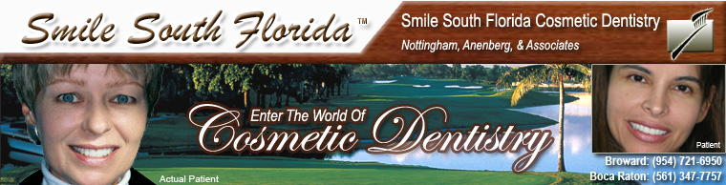

Released on = July 29, 2007, 9:17 am
Press Release Author = Smile South Florida Cosmetic Dentistry
Industry = Healthcare

Press Release Summary = Smile South Florida Cosmetic Dentistry adds Vizilite Plus® oral cancer screening to its offering of services.
Press Release Body = July 30, 2007—MIAMI, BOCA RATON AND FORT LAUDERDALE, FLORIDA— Smile South Florida Cosmetic Dentistry recently began offering Vizilite Plus® oral cancer screenings.
The practice began offering the screenings in June, in light of the fact that about 30,000 new cases of oral cancer are diagnosed each year in the United States, said Dr. Charles Nottingham, a cosmetic dentist who is the senior partner of Smile South Florida Cosmetic Dentistry. When caught at its earliest stage, oral cancer can be cured relatively easily.
“We opted to begin conducting the ViziLite Plus® exam because it will help us identify abnormal tissue that might develop into oral cancer,” Nottingham said. An annual ViziLite Plus® exam, in combination with a regular visual examination, provides a comprehensive oral screening procedure for patients at increased risk for oral cancer.
Although adults should be screened annually for oral cancer, Nottingham said, men older than age 40 who use tobacco products and drink more than one alcoholic beverage per day are at the highest risk of developing oral cancer.
“They certainly should consider the screening,” he said, adding, “Anyone who uses tobacco products should be screened for oral cancer.”
The ViziLite Plus® exam is painless, fast and non-invasive, according to the company’s Web site, www.vizilite.com.
The ViziLite Plus® exam is performed immediately following a regular visual examination. The first step is to rinse with a cleansing solution. Then, the overhead lighting is dimmed and the dentist examines the mouth using ViziLite Plus®, a specially designed light technology. This light technology causes abnormalities that may not be seen by the naked eye to glow a bright white.
If you would like to learn more about oral cancer screening or speak to a professional to determine whether you should be screened, call Smile South Florida today at (954) 721-6950 in Broward County, (561) 347-7757 in Boca Raton visit our website at www.smilesouthflorida.com.
About Smile South Florida Cosmetic Dentistry
The dentists at Smile South Florida Cosmetic Dentistry have offices in Broward County and Boca Raton and serve patients from Boca Raton to Fort Lauderdale and Miami. In addition to being trained in the ViziLite Plus® oral cancer screening procedure, they specialize in porcelain veneers, dental implants and extreme makeovers.
© 2007 Sinai Marketing and Smile South Florida Cosmetic Dentistry. Authorization to post is granted, with the stipulation that Sinai Marketing is credited as sole source. Linking to other sites from this press release is strictly prohibited, with the exception of herein imbedded links.
Web Site = http://www.smilesouthflorida.com
Contact Details = Broward County Office
7401 N. University Dr., Ste. 207
Tamarac, FL 33321
Tel: (954) 721-6950
Fax: (954) 726-4292

