Smile South Florida - Broward County Cosmetic Dentist Becomes Lumineers® Certified
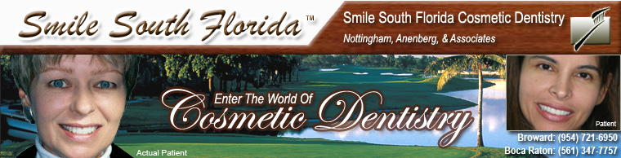

Released on = July 15, 2007, 5:12 pm
Press Release Author = Smile South Florida Cosmetic Dentistry
Industry = Healthcare
Press Release Summary = LUMINEERS® porcelain veneers are a painless, non-invasive way to brighten and align teeth without altering their natural structure.
Press Release Body = July 16, 2007—MIAMI, BOCA RATON AND FORT LAUDERDALE, FLORIDA— Smile South Florida Cosmetic Dentistry recently certified in the application of LUMINEERS® BY CERINATE®, an alternative to traditional porcelain veneers.
Dr. Charles Nottingham, a cosmetic dentist who is the senior partner of Smile South Florida Cosmetic Dentistry, said the practice began offering LUMINEERS® due to numerous patient requests for the product.
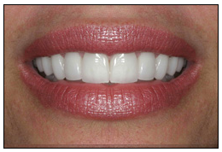
“This option is good for people who have a fear of the dentist or don’t want their teeth drilled on,” Nottingham said. “People who have Tetracycline-stained teeth typically are good candidates for this procedure.”
LUMINEERS® provide a painless way to permanently whiten and align teeth and repair chipped teeth without altering tooth structure. Traditional porcelain veneers require teeth to be shaped and grinded to ensure a proper fit.
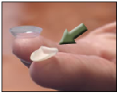
LUMINEERS® are similar in thickness to a contact lens and they adhere to teeth in their current state- very little shaping or grinding may be necessary, Nottingham said. They can even be placed over existing crown or bridgework without having to replace them.
“They are easy to apply and much more convenient for a patient,” he said.
LUMINEERS® are applied in up to three visits and because of their strength and durability, they have been clinically proven to last more than 20 years. The procedure usually is completely reversible if desired.
Once they are affixed to the teeth, no additional maintenance is required with LUMINEERS®, other than a follow-up visit to your dentist and proper brushing and flossing on a daily basis.
If you would like to learn more about LUMINEERS® or you would like to speak to a professional to determine whether you are a candidate for the porcelain veneers, call Smile South Florida today: (954) 721-6950 in Broward County; (561) 347-7757 in Boca Raton; or email us to schedule an appointment.
About Smile South Florida Cosmetic Dentistry
The dentists at Smile South Florida Cosmetic Dentistry have offices in Broward County and Boca Raton and serve patients from Boca Raton to Fort Lauderdale and Miami. In addition to offering LUMINEERS®, they specialize in dental implants and extreme makeovers.
© 2007 Sinai Marketing and Smile South Florida Cosmetic Dentistry. Authorization to post is granted, with the stipulation that Sinai Marketing is credited as sole source. Linking to other sites from this press release is strictly prohibited, with the exception of herein imbedded links.
Web Site = http://www.smilesouthflorida.com
Contact Details = (954)721-6950

