Sydney Parents Children's and Baby Expo success for Fertile Mind available in the US


Released on = July 1, 2007, 8:47 pm
Press Release Author = Fertile Mind Pty Ltd
Industry = Apparel & Fashion
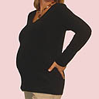
Press Release Summary = Fertile Mind displayed their great products, particularly their new super silky Soft Shirt at the 2007 Sydney Parents Children’s and Baby Expo, many of these products are also available in the US.
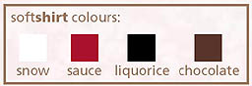

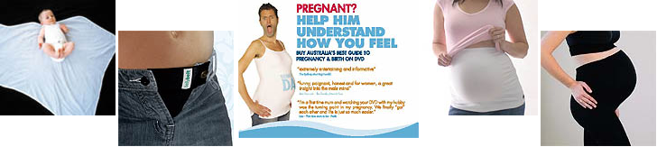
Press Release Body = The Sydney Parents Children's and Baby Expo held in Australia was on over the first weekend in June. Sydney residence had the opportunity to meet the Fertile Mind team and have a look at their great maternity and breastfeeding clothing. They had some great gift ideas - Lalito Shaped Baby Wrap (the wrap "for dummies"), Opaque winter maternity tights (you can cut off the feet for footless and wear when you're not pregnant too), Being Dad DVD (they loved it on "Sunrise"), and their world famous Belly Belt Combo (the must-have for early pregnancy). A new product the really got some attention was Fertile Minds Soft Shirt – they are so comfortable many had to buy one, including Christine the Director herself and she wasn’t pregnant. Super silky soft, the quality was obvious. They are great for pregnancy, breastfeeding and even as nightwear. Available in a delicious palette of colours - sauce (red), snow, liquorice or chocolate. These are now available to US customers via their US website www.fertilemind.com – enjoy their great service.
Web Site = http://www.fertilemind.com/maternity-wear
Contact Details = Fertile Mind
6893 Sullivan Road
Grawn MI 49637
(562) 508 4271
fertilemind@netordering.com

