Sydney Parents Children's and Baby Expo success for Fertile Mind


Released on = July 1, 2007, 8:51 pm
Press Release Author = Fertile Mind Pty Ltd
Industry = Apparel & Fashion
Press Release Summary = Fertile Mind launched their new service MumsCoach as well as displayed lots of their great products, particularly their new super silky Soft Shirt at the 2007 Sydney Parents Children’s and Baby Expo.
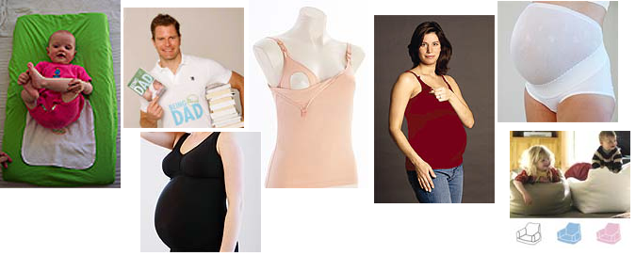
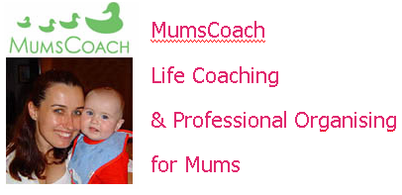

Press Release Body = Sydney Parents Children's and Baby Expo was on over the first weekend in June, Sydney residence had the opportunity to meet Fertile Mind’s MumsCoach, their online life coach and professional organiser for mums on the Friday as well as having a look at their great maternity and breastfeeding clothing. MumsCoach is now available there through www.fertilemind.com.au or www.mumscoach.com.au. They had some great gift ideas for under $30 - Lalito Shaped Baby Wrap (the wrap "for dummies"), Lalito Change Mat Covers, Opaque winter maternity tights (you can cut off the feet for footless and wear when you're not pregnant too), Being Dad DVD (they loved it on "Sunrise") , Bando (hugs the tummy and looks great), Belly Belt Combo (the must-have for early pregnancy) and ExpectantSee screensaver (you've got to try this - animated pregnancy timeline). A new product the really got some attention was Fertile Minds Soft Shirt – they are so comfortable many had to buy one, including Christine the Director herself and she wasn’t pregnant. Super silky soft, the quality was obvious. They are great for pregnancy, breastfeeding and even as nightwear. Available in a delicious palette of colours - sauce (red), snow, liquorice or chocolate. RRP $59.95

Web Site = http://www.fertilemind.com.au/maternity-wear
Contact Details = Fertile Mind Pty Ltd
Unit 12, 84 Old Pittwater Road
Brookvale NSW 2100
Phone: +61 2 9905 0199
Fax: +61 3 9905 0322
sales@fertilemind.com.au

