Zodiac Babies Sales from Fertile Mind and Perfect Fit Pop Maternity Undies

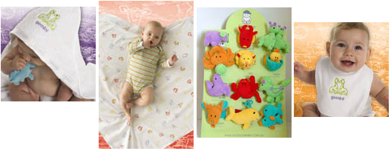
Released on = July 1, 2007, 8:51 pm
Press Release Author = Fertile Mind Pty Ltd
Industry = Apparel & Fashion
Press Release Summary = Great opportunity to buy something for a friend having a baby, Perfect Fit Pop Maternity Undies have customers coming back for more and sell out of Extra Long Tanks extra order to be flown in.
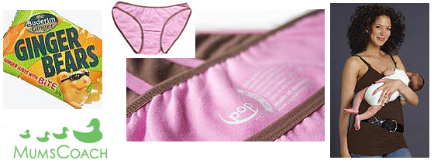
Press Release Body = Fertile Mind is discounting their Zodiac Babies range. With giant towels and super soft baby wraps the huge sale is a great opportunity to buy something for a friend having a baby. Think ahead for Christmas! They have also added the Perfect Fit pregnancy undies to their website. The Pop Maternity Undies where a huge hit with all the female staff. At the recent baby expo, Christine the company director shared that one customer came two days in a row to buy more of them. They have also been amazed at the popularity of their new Glamourmom Nursing Extra Long Tanks which almost sold out in 24 hours to stockist around the country, so they have organised to flying more in to meet the demand. These will be available in Chocolate, Mid-night Blue and Black. Their Ginger Bears jubes are being found in the glovebox and handbags of nauseous pregnant women, and they are also handy for warding off travel sickness. They are safe for kids and gluten free, these "gummy bears" contain fresh ginger which is clinically proven to help alleviate any kind of nausea. Only a month ago Fertile Mind launched MumsCoach which has kept their Life Coach & Professional Organiser busy, but also beaming with satisfaction. Clients are varying from the early stages of pregnancy wanting to get a head start to planning for their "new life" and experienced mums looking for support in their "crazy lives". Fertile Mind is sponsoring Kylie's fees for 2007, so you should take advantage of this great service now and improve your parenting potential.
Web Site = http://www.fertilemind.com.au/maternity-wear
Contact Details = Fertile Mind Pty Ltd
Unit 12, 84 Old Pittwater Road
Brookvale NSW 2100
Phone: +61 2 9905 0199
Fax: +61 3 9905 0322
sales@fertilemind.com.au

