CelTrek Creates New Standards for Global Roaming Benchmarks set for International SIM Cards

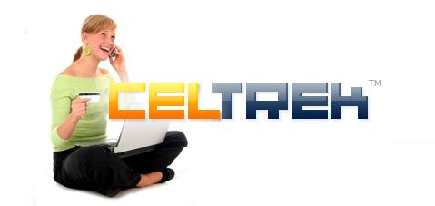
Released on = August 18, 2007, 8:26 pm
Press Release Author = Company PR
Industry = Advertising
Press Release Summary =CelTrek, the first US based company that offers one SIM card for 165 countries including free US, UK or French phone numbers, has now upgraded its service with these features:
Press Release Body = (August 15, 2007, Miami, FL) Only six months after the launch of the highly anticipated CelTrek SIM card, the company has announced they are ahead of schedule in adding new advances to their SIM card and website capabilities.
“We have two goals in mind for CelTrek. One, to be the most fully loaded global roaming tool for travelers, and two, to offer distributors all they need to penetrate the world wide need for such a product,” says Florian Seroussi, CelTrek CEO.
CelTrek, the first US based company that offers one SIM card for 165 countries including free US, UK or French phone numbers, has now upgraded its service with these features:
* | Call forwarding via the CelTrek Web site to any phone number worldwide. For example CelTrek users can forward the CelTrek phone number to their US number when back home.
* | CelTrek caller ID. The CelTrek phone number is displayed to call recipients.
* | Recharge airtime by phone via pin code or scratch card, in addition to recharging over the CelTrek webpage.
* | Check balance, check number, add credit, etc, straight from the CelTrek phone.
* | An increased number of compatible devices that work with the CelTrek service.
“These features were not required to measure up to the other SIM products on the market, but as part of our desire to create a true world phone capability.” Mr. Seroussi continues. “The advanced functions, the ease of use, and yes, of course the fact that our users can save up to 90% over roaming costs from other US carriers, makes us proud to say, you can feel free to move about the planet and communicate as you would from home or office.”
Miami, FL based CelTrek was created by Global Roaming, Inc.. With over 350 GSM network operator agreements covering 165 countries, CelTrek users roam on conventional cellular systems at greatly reduced rates.
CelTrek is a pre-paid service, with no contracts, or minimum usage requirements. Users simply buy CelTrek SIM cards, airtime, and GSM phones, check rates and manage their CelTrek account online at, www.celtrek.com. CelTrek provides solutions for corporate clients and offers distribution opportunities.
Web Site = http://www.CelTrek.com
Contact Details = Jenny Callicott, COO, CelTrek
jenny@celtrek.com
305 249 3121
213 268 0700

