Paper, Plastic or ME?
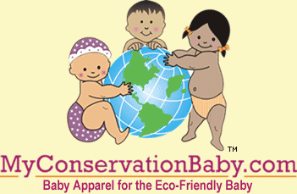

Released on = August 27, 2007, 4:04 pm
Press Release Author = Ellen McNeill/MyConservationBaby.com
Industry = Apparel & Fashion
Press Release Summary = How can a shopper easily contribute to saving energy and reducing waste and litter? MyConservationBaby.com has a simple way to make it happen.
Press Release Body = MyConservationBaby.com, the first online baby boutique offering baby onesies and toddler tees with conservation messages such as Protect the Environment announces a new addition to its family. The Paper, Plastic or ME? tote is an eco-friendly 100% cotton black canvas reusable “grocery bag” that can go everywhere a shopper goes. This will help the shopper reduce waste by not having to select paper or plastic that will most likely be used just once. It offers an option of picking the lesser of two evils.
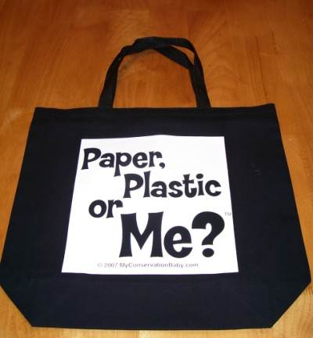
The Paper, Plastic or ME? tote is 16” high X 18” wide with a 5” gusset and takes the place of approximately 2-3 plastic bags used at the grocery store. When designing the Paper, Plastic or ME? tote Ellen McNeill, owner of MyConservationBaby.com researched plastic bag usage. Her research revealed that the average individual uses thousands of plastic bags during their lifetime. She found three questions that shoppers should ask when they are automatically handed a plastic bag when they are shopping:
• Do I need a plastic bag for this item that is already well packaged by the manufacturer?
• Do I need to take as many plastic bags in supermarkets?
• Could I bring my own shopping bag when making purchases?
Plastic bags are the cause of major environmental concerns. Somewhere between 500 billion and a trillion plastic bags are consumed worldwide each year. Research shows that millions of plastic bags end up as litter. Plastic bags have been seen blowing down the street or even in trees. Once a plastic bag is in the environment, it takes months to hundreds of years for it to break down. McNeill suggests that a Paper, Plastic or ME? tote is a common sense alternative to plastic and to paper. She reports that the tote is getting rave reviews from professional product reviewers.
Shauna Greer, reviewer for Celebrity Baby Clothes, compares the MyConservationBaby.com Paper, Plastic or ME? tote to designer Anya Hindmarch's "I Am Not A Plastic Bag" tote recently in the headlines. Shauna says, “We have the new ‘IT’ shopping tote for you, one that's way more practical, affordable and fresh. Made with black durable cotton and a cheeky phrase, it will keep you and baby chic as you shop. It fits a ton of groceries and you'll be helping out Mother Earth by reducing your use of plastic bags.”
Candace Llindemann, owner of Mamanista.com of Southold, New York says, “I have already gotten some great comments on my Paper, Plastic, or ME? reusable tote bag and I am starting to see them pop up all over New York! This is sure to be a hot item this season as new parents look for ways to model their values for their impressionable little ones.”
A few countries and cities have already taken tangible action to reduce the number of plastic bags used. Ireland, Taiwan, South Africa, Australia and Bangladesh heavily tax plastic bags and have banned their use entirely because they have become such an environmental problem. It has been reported that England and some U.S. cities are considering similar actions.
Paper and plastic bags both come at a great cost to the environment. Instead of accepting paper or plastic at the supermarket a shopper can now use the Paper, Plastic or ME? tote. Any shopper can help make a difference to the environment and to the future of babies all around the world by reducing the number of plastic bags they use.
Web Site = http://www.MyConservationBaby.com
Contact Details = 69 Shadow Ridge Drive
Fletcher, NC 28732 USA
828.681.9688 (Office)
828.681.9690 (Fax)
info@MyConservationBaby.com

