Texas Micro-Bead Pillow Provides Double Benefit For Breast Cancer Patients


Released on: September 29, 2007, 8:40 am
Press Release Author: James A. Margrave / Dot Anderson
Industry: Biotech
Press Release Summary: Canton, TX - September 28th, 2007 - Snooztime, Inc. announces the introduction of the Pink Ribbon pillow to be sold at the TX St Fair and online. Snooztime pledges 100% of profits to Cancer Charities. Extraordinary comfort is one of the primary benefits to patients who have had a Mastectomy or Lumpectomy.
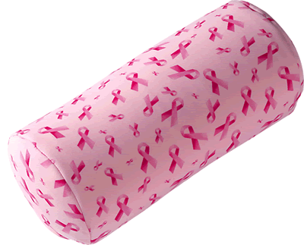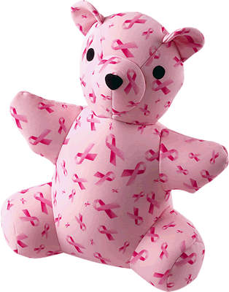
Press Release Body: Ask someone what goes on in Texas in October and they’ll likely say the Texas State Fair or National Breast Cancer Awareness Month. Snooztime, Inc., a manufacturer of microbead pillows will utilize their booth in the Grand Place Exhibit Building to introduce fair goers to their Pink Ribbon mini pillows and teddy bears and will donate 100% of the profits from these items sold at the fair to cancer charities.
“Hundreds, if not thousands of companies offer pink or pink ribbon products that support breast cancer research, but most of these products don’t offer a direct benefit to the breast cancer patient,” said Donna Harmon, president and co-founder of Snooztime. “Our microbead mini pillows are the perfect size for providing special support to cancer patients following mastectomies and lumpectomies and our baby bears are comforting.”
“Through response from our customers, we realized there was a far greater use for microbead pillows than we ever imagined,” added Harmon. “When we found out that many mastectomy patients were using our mini pillows, we decided to introduce them with a cheerful pink ribbon covering. Our goal is to bring extra comfort to breast cancer patients as well as raise awareness for breast cancer and help provide financial support for cancer charities.”
Microbead pillows are the newest innovation in pillow technology. Unlike memory foam pillows, microbead filled pillows instantly adjust to head, neck and body shape. This means that during sleep, the microbead pillow continuously changes and adapts to reduce or equalize pressure so that the head and neck or body area is comfortably supported.
Snooztime pillows use denatured, food grade, closed cell micro beads, which are small, smooth and nonabsorbent. Because the beads are spherical, they always maintain small airflow gaps between each one. This allows for positive airflow throughout the pillow, which disperses heat making the pillow cooler and more comfortable. Snooztime’s microbead pillows are also naturally hypoallergenic and resist the growth of mold, mildew and bacteria. They are completely machine washable.
This area company makes a complete line of microbead pillows including personal and mini size roll pillows, U-shaped pills for the neck, personal size flat travel pillows, full size bed pillows and body pillows. The company also makes pet pillows and ultra soft teddy bears.
About Snooztime, Inc.
Snooztime, Inc, is a small family-owned business founded in 2004 by David and Donna Harmon. Based in Canton, TX, the company manufactures a complete line of microbead pillows including full size luxury bed and body pillows, personal and travel size pillows, and pet pillows. The company was founded on business principals that include tradition, integrity and family values. Snooztime, offers a 30-day risk free trial of their products.
Web Site: http://www.snooztime.com/pink_ribbon.php
Contact Details: Snooztime, Inc.
231 VZCR 4104
Canton, TX 75103
Contact:
James A. Margrave
Operations Manager
903-567-5258 Office
903-567-4698 Fax
james@snooztime.com

