What Artisans Don't Know About Craft Photography But Wish They Did

Released on: September 8, 2007, 5:15 pm
Press Release Author: Jim Juris
Industry: Apparel & Fashion
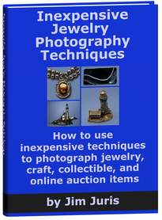
Press Release Summary: This is a press release to announce a new ebook specifically written for jewelry and craft artists by Jim Juris. This ebook was written to teach artisans how to take better photographs of the beautiful creations in order to sell their products online.
Press Release Body: FOR IMMEDIATE RELEASE
Jim Juris
voice (303) 762-1601
JRJ_50@yahoo.com
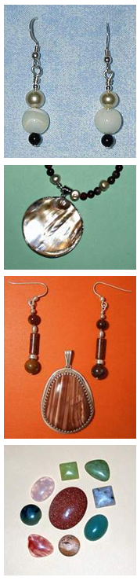
When it comes to photographing jewelry and crafts many artisans quickly find out that it is not as easy as they think.
Dateline: Englewood, Colorado. September 8, 2007
Many jewelry artists make fantastic jewelry but they lack the knowledge needed for taking great photographs of their beautiful work. Jim Juris discovered this several years ago when he began making jewelry and participating in online jewelry forums. The images that many jewelry artists where placing on their web site or showing to other members on jewelry forums lacked quality.
Jim Juris felt a strong desire to help jewelry artists improve their jewelry photography. He felt that the best way for him to do this would be to write an easy to read, easy to understand, informative ebook on jewelry photography. His other objective in writing this ebook was to show people how to improve their jewelry photography inexpensively. It would be very easy for a person to spend several hundred dollars up to a thousand dollars or more on lighting and a photo light box, but Juris shows people how to take good photographs of jewelry using inexpensive materials that can be purchased for under one hundred dollars, excluding the cost of a digital camera and a tripod.
Jim Juris is an ebook author and a photographer who enjoys helping people improve their photography. Information about his jewelry photography ebook can be found at http://www.InexpensiveJewelryPhotography.com.
"Although I enjoy making jewelry, my real talent and passion is in photographing jewelry and craft items", said Juris, the author of a new 57 page ebook titled-- Inexpensive Jewelry Photography Techniques: How to use inexpensive techniques to photograph jewelry, craft, collectible, and online auction items.
This ebook is written for those jewelry and craft artists that need help photographing their creations and placing their images on a web site for online sales.
###
Web Site: http://www.inexpensivejewelryphotography.com/
Contact Details: FOR MORE INFORMATION
Contact Jim Juris
voice (303) 762-1601
JRJ_50@yahoo.com
www.InexpensiveJewelryPhotography.com

