Grooms Opt for Titanium Rings Due to Meteoric Rise in Precious Metals


Released on: October 30, 2007, 9:49 am
Press Release Author: Sbrown/Titanium-Jewelry
Industry: Apparel & Fashion
Press Release Summary: Contemporary Metals Offer Affordable Alternatives for Men's Wedding Bands
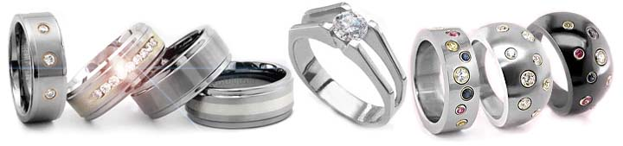
Press Release Body: (Modesto, CA) October 29, 2007 – Titanium-Jewelry.com, a leading online retailer of titanium rings, tungsten rings and unique titanium jewelry, today announced that affordable and stylish alternatives are highly demanded as price increases in precious metals limit options for grooms seeking men's wedding bands.
Across the United States and abroad, many grooms have discovered that they are being priced out of the market when shopping for traditional wedding bands in gold and platinum. The average person does not pay attention to the price of gold, platinum and other precious metals on a regular basis. As such, most do not know that the cost of men's wedding bands made of platinum or gold, have tripled in cost over the last 5 years. "It can be shocking when a young man heads into the jewelry store with his fiancée and eyes a basic platinum wedding band selling for $2,000, or more. With the rising costs of weddings, many grooms simply can no longer afford the traditional platinum wedding band," stated Ron Yates, founder of Titanium-Jewelry.com and owner of Yates & Co Jewelers in Modesto, CA.
The reason for the dramatic increase in men's wedding bands made of white gold or platinum is due to the rising cost of precious metals, which have increased by as much as 30% over the past year. The price of gold has risen from $600 per ounce to over $750 per ounce. Platinum has also increased from $1100 to over $1400 per ounce since this time last year. According to Curtis Hesler, editor of the Forbes Newsletter, The Professional Timing Service, "The first quarter of next year, could see gold push the $800 level." The increases in the precious metal market, has negatively affected the choices available to many couples looking to select wedding or other fine jewelry.
The solution: modern, alternative metals such as Titanium, Black Titanium and Tungsten Carbide. For the past several years many younger grooms have been purchasing titanium and tungsten wedding bands mainly for their durability and hypoallergenic qualities.
However, cost is becoming the primary motivating factor. With the increasing number of younger grooms being priced out of gold or platinum wedding bands, couples are overwhelmingly choosing contemporary metals. Wedding bands made of Titanium, Black Titanium, Tungsten Carbide and Carbon Fiber, are viable choices for wedding bands and wedding rings, offering customers affordable quality and modern styling.
Platinum wedding bands for men in 6mm widths are selling for $2,000 and more. Titanium rings and tungsten rings in the same widths can be purchased at a fraction of the cost. A leading online retailer of contemporary jewelry, Titanium-Jewelry.com, has many styles of tungsten and titanium wedding bands for as low as $79.
"We've seen a huge increase in men choosing contemporary metals for their wedding rings. Just three or four years ago most guys never heard of titanium rings or tungsten rings," stated Yates. "Now couples are considering these rings as a viable choice for their wedding rings. They like modern designs, durability and the affordability," Yates concluded.
Titanium-Jewelry.com has many styles and price points to choose from, offering couples more affordable solutions, without compromising quality, style or comfort. For more information on titanium rings and tungsten rings, please navigate to http://www.titanium-jewelry.com.
About Titanium-Jewelry.com
Titanium-Jewelry.com provides a wide selection of titanium rings and jewelry unique style for men and women. As a complement to Yates & Co Jewelers, the brick-and-mortar counterpart to Titanium-Jewelry.com, customers have relied upon receiving the highest quality products from the most respected titanium jewelry experts in the field. Titanium-Jewelry.com guarantees their jewelry is made from ultra high grade titanium alloys and provides unparalleled customer service and accessible expertise in titanium rings and jewelry, equaling the best possible online shopping experience. Founded in 1988, Titanium-Jewelry offers the best selection of custom fine jewelry with unique and original designs, antique and estate pieces plus a complete line of titanium jewelry for men and women. For more information, please visit www.Titanium-Jewelry.com.
Web Site: http://www.Titanium-jewelry.com
Contact Details: Press Contact
Ron Yates
Founder
Phone: 800-370-2646
Email: ron@titanium-jewelry.com

