KVM Tools Shares Their Success and Growth!!


Released on: October 23, 2007, 8:18 am
Press Release Author: Donald O Malley
Industry: Advertising
Press Release Summary: KVMTools.com a leading value-added reseller today announced that it now offers more than 400 manufacturers offering the large selection of power tools, air tools and hand tools as well as fasteners, and accessories available at guaranteed lowest prices.
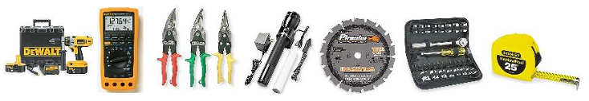
Press Release Body: KVMTools.com a leading value-added reseller today announced that it now offers more than 400 manufacturers offering the large selection of power tools, air tools and hand tools as well as fasteners, and accessories available at guaranteed lowest prices.
KVM Headquarters, parent company of KVM Tools is very excited about the success and growth of KVM Tools. Customers can select their chosen products either by clicking on one of the categories in the left-hand navigation or by using the search function. For those who want a more defined search, the advanced search function allows customers to search by term with the added benefit of allowing brand(s) to be selected. KVM Tools has highly qualified account managers who will guide through every step of the checkout process, in order to ensure a smooth and seamless order process.
"The variation of products available on KVM Tools website now allows the customers to get all of their construction projects done on time and on budget." said Donald O Malley, Product Manager at KVM Headquarters.
To view the new website or to learn more about KVM Tools, please visit: http://www.kvmtools.com To view the brands carried by KVM Tools, please visit http://www.kvmtools.com/servlet/Page?template=Brands
About KVM Headquarters (KvmHq.com)
KVM Headquarters is a leading value-added reseller based in Sugar Land, TX, offers a wide selection of KVM Switches, Adapters, Cables, Extenders, and Splitters. Furthermore, the company has set itself apart from its competitors by offering unparalleled customer service and a fast order system. For more information, please visit KvmHQ.com
About KVM Tools (KvmTools.com)
KVM Tools, based in Sugar Land, TX. is a leading provider of large selection power tools, air tools and hand tools as well as fasteners, and accessories. KVM Tools has a large selection of power tools, air tools and hand tools as well as fasteners, and accessories available at guaranteed lowest prices to help get all of your construction projects done on time and on budget.
Web Site: http://www.kvmtools.com
Contact Details: KVM Headquarters
Donald O’Malley
1-888-494-5499
sales@kvmhq.com
sales@kvmtools.com
http://www.kvmhq.com
http://www.kvmtools.com
P.O. Box 17752
Sugar Land, TX 77496

