Black - The Color of Jewelry This Season


Released on: November 19, 2007, 4:14 pm
Press Release Author: Sbrown/Titanium-Jewelry
Industry: Apparel & Fashion
Press Release Summary: Black diamond jewelry featuring black titanium anniversary rings and black titanium with black diamonds wedding bands driving fashion trends this season.
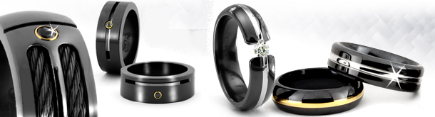
Press Release Body: (Modesto, CA) – Titanium-Jewelry.com, a leading online retailer of black titanium rings, tungsten rings and unique black titanium with black diamonds for men and women, today announced that many of their black diamond jewelry pieces and black titanium anniversary rings have experienced increased interest and inquisitions as black on black heats up retail stores.
Black has been used frequently in designs for the fashion world from everything from cell phones to black satin trench coats, boots and black on black attire. In a November 9, 2007 article on fashion trends in Japan, "black is fashionably back." The website, web-japan.org commented on the rise in black fashions among today's fashion savvy stating that many are "creating an effect not with colors but with subtly different materials and textures is a key to the fashion scene this autumn."
This latest trend doesn't just touch clothing and apparel, but has seen its course in jewelry as well. With the new craze of black being the color of choice among many people, jewelry designers have been featuring black diamonds and black titanium more often in recent design. David Yurman & Tiffany are now selling black titanium jewelry. Edward Mirell, well known for his collection of titanium jewelry, has designs featuring black titanium with black diamonds.
"We've seen a huge increase in interest from customers about black diamonds, especially black titanium with black diamond wedding bands," stated Ron Yates, founder of Titanium-Jewelry.com and owner of Yates & Co Jewelers in Modesto, CA. "We've added many black titanium anniversary rings, and black diamond wedding bands for couples looking for unique and fashionable wedding jewelry," Yates concluded.
Black diamonds became popular in the early 1990's with renewed interest from celebrities and fashion enthusiasts alike. Black diamonds, named "carbonados", were first discovered back in 1840 in Brazil and are primarily found in Brazil and the Central African Republic. The revived trend for black jewelry parallels the season's hottest fashions detailing cool, sleek and sophisticated. For more information on black diamond jewelry, please visit http://www.titanium-jewelry.com/black-diamonds.html
About Titanium-Jewelry.com
Titanium-Jewelry.com provides a wide selection of tungsten rings, titanium rings and black titanium jewelry uniquely styled for men and women. Experts in modern mens wedding bands, and modern metals jewelry, Titanium-Jewelry.com leads the industry in contemporary jewelry fashions. For more information, please visit www.Titanium-Jewelry.com.
#
Web Site: http://www.Titanium-jewelry.com
Contact Details: Press Contact
Ron Yates
Founder
Phone: 800-370-2646
Email: ron@titanium-jewelry.com

