H.Samuel launch new exclusive Julien Macdonald jewellery collection
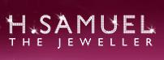

Released on: November 2, 2007, 3:29 am
Press Release Author: H.Samuel
Industry: Apparel & Fashion
Press Release Summary: Fashion designer to the stars, Julien Macdonald, is launching his first jewellery collection, available exclusively at H.Samuel
Press Release Body: H.Samuel the Jeweller has announced a strategic partnership with jewellery designer Julien Macdonald, launching four exclusive ranges of designer jewellery for the UK jewellery chain. Known for high octane glamour, the Welsh born designer has worked his magic to create four truly spectacular capsule collections, each with a different theme: Geometric, Flower, Facet and Chandelier.
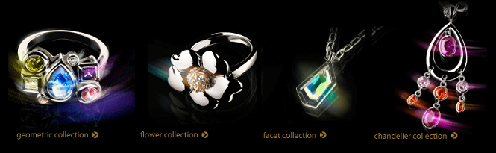
“I wanted to design for H.Samuel because it’s a shop I remember going to as a kid with my mum and I’ve got a real soft spot for it. I wanted to create four glamorous and luxurious collections, so that each provides that all important final touch to an outfit, whatever your style. Every piece uses stones and crystals in gorgeous vibrant colours for a bit of real life red carpet chic”, commented Julien Macdonald.
The eclectic list of inspirations for the Julien Macdonald H.Samuel collection include the natural beauty of Spring flowers, the dramatic abstract lines of crystal stones and the paintings of iconic Art Deco artist Tamara de Lempicka.
The Geometric designer jewellery collection makes a statement with clusters of eye-catching stones allowing customers to choose individual pieces or the full collection for maximum effect.
Alternatively, the Facet range mixes clean angular lines with dazzling Swarovski crystals which can be coordinated with an essential black dress in order to dazzle just in time for the party season
Femininity takes shape in the Flower Collection reflecting the nature trend with a beautiful combination of Swarovski crystals and highly polished metal.
The Chandelier collection oozes party glamour to provide an essential drop pendant and chandelier earrings, both featuring vivid pink and orange stones for stand out.
This stunning limited edition collection of 12 pieces retails from £25 for the Flower crystal ring and goes up to £95 for a sparkling Geometric multi-colour cubic zirconia necklace.
With the Julien Macdonald for H.Samuel collection, every girl can feel like a star.
Notes to Editors:
As the nation’s favourite jeweller with 375 UK stores, H.Samuel stocks a comprehensive collection of jewellery, branded watches, collectibles and original gift ideas. H.Samuel is part of Signet Group plc, the world’s largest speciality retail jeweller.
May 2007 Signet operated 1,910 speciality retail jewellery stores; including 1,332 stores in the US, where the Group trades as "Kay Jewelers", "Jared The Galleria Of Jewelry" and under a number of regional names. At that date Signet operated 578 stores in the UK, where the Group trades as "H.Samuel", "Ernest Jones" and "Leslie Davis".
H.Samuel PR Contact:
Naomi Dodson
Yellowdoor
22 Torrington Place
London
WC1E 7HJ
020 7580 0707
http://www.hsamuel.co.uk/
Web Site: http://www.hsamuel.co.uk/
Contact Details: H.Samuel PR Contact:
Naomi Dodson
Yellowdoor
22 Torrington Place
London
WC1E 7HJ
020 7580 0707
http://www.hsamuel.co.uk/
enquiries@pr-sending.co.uk

