Ras Al Khaimah to emulate the success of Dubai according to Select Property


Released on: November 21, 2007, 2:05 am
Press Release Author: Select Property
Industry: Real Estate
Press Release Summary: Select Property discover a hidden gem in the UAE
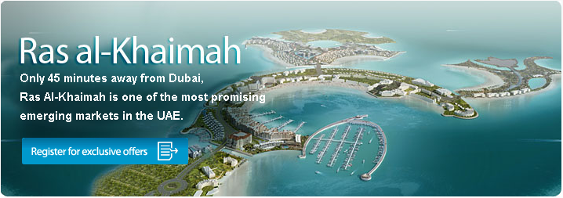
Press Release Body: When most people think of the United Arab Emirates Dubai immediately comes to mind, but according to overseas property specialist, Select Property, another Emirate is on course to emulate Dubai’s property investment and tourism success. Just 45 minutes drive North of Dubai, Ras Al Khaimah is rising in popularity due to its low land costs, tax benefits, picturesque landscape and commutable distance to Dubai.
In contrast to Dubai’s city atmosphere, Ras Al Khaimah offers a more relaxed way of life. Pure white sands, lush green landscapes and mountain scenery offer wide appeal to Dubai residents who want to work in the city but live by a beach, as well as attracting a growing number of holidaymakers.
Using Dubai’s success as an example, Ras Al Khaimah’s ruling Sheikh has undertaken various initiatives to meet its tourism target of 2.5 million by 2012. These plans have already increased the level of tourism by over 219% between 2005 and 2006.
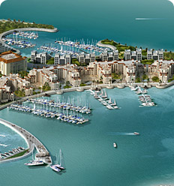
The latest off-plan offering from Select Property is the La Hoya Bay Residence located on the man made Al Marjan Island. Inspired by the famous Palm and World Islands, along the coast of Dubai, Al Marjan Island is a series of five isles stretching 2km into the Gulf of Persia. All La Hoya Bay Residence apartments capture the essence of living a beach front lifestyle complete with views overlooking the sea or private marina. The residence features multi-sized spacious apartments, including studios, one and two bedrooms, with prices starting from just £49,170.
Mark Stott, Select Property Managing Director, believes there are many reasons to buy in Ras Al Khaimah, “Not only does Ras Al Khaimah offer luxury housing at affordable prices but it has great potential for capital gains and rental returns, due to the ruling sheikh’s commitment to developing the region and attracting inward investment. Some developments have already seen their prices increase by 20% annually for the past two years. La Hoya Bay itself will appeal to both tourists and residents due to its beachfront location, extensive facilities and close proximity to Dubai.”
La Hoya Bay development facilities include an on-site tennis club, a variety of restaurants and a nightclub, five star health club and spa, 3 outdoor temperature controlled swimming pools and valet parking.
- END -
About Al Marjan Islands
Located 27km southwest of Ras Al Khaimah town centre, Al Marjan Islands is the first man-made island project to be developed in the emirate. The Islands will comprise five man-made coral-shaped islands. It will contain 10 major hotel sites, 50 large villa sites, a marina and marina village, plus a water theme park.
The master developer, Rakeen does not favour ‘hostile dredging’ to create the man-made islands. They have instead used surface fill with coarse earth material to create the Al Marjan Islands. Over two million pieces of natural rock have been cautiously and carefully laid to construct the essential breakwaters. In the long term, the rocks will attract coral life and help a reef formation, giving birth to a new ‘natural’ wonder in RAK and a breathtaking underwater paradise unique to the Arabian Gulf.
About Select Property:
Select Property specialise in supplying overseas property for investment purposes. The company has been operating from 2004 and has to date successful sold over £300 million worth of properties in Dubai, Spain, Bulgaria and Turkey. The company formerly traded under the name Dubai Select before consolidating its country-specific brands under the Select Property banner in January 2007.

Web Site: http://www.selectproperty.com/
Contact Details: PR contact:
Kirsty Barry
Select Property
The Box
Brooke Court
Lower Meadow Road
Wilmslow
Cheshire
SK9 3ND
0161 488 3552

