The arrival of the Kate Moss Topshop collection for Christmas 2007 is here


Released on: November 19, 2007, 4:11 am
Press Release Author: Topshop
Industry: Apparel & Fashion
Press Release Summary: Kate Moss and Topshop present their Christmas 2007 capsule collection of stylish signature pieces
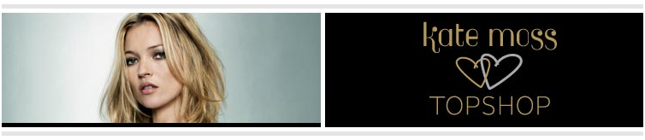
Press Release Body: Kate Moss and Topshop present their fourth capsule collection of signature pieces for Christmas. Kate encapsulates her ever-changing sense of style with an exquisite collection of embellished pieces that further echo the luxury rock and roll feel of the Autumn/Winter collection currently in store.
The new Christmas Kate Moss collection for Topshop comprises beautiful dresses, fine gauge knits, intricate lace capes and sharp Saville Row-inspired tailoring, accented by studded accessories.
Referencing Patti Smith, Victoriana, and the glamour of the 1930s, the collection takes the customer from the chicest girl in the office to sex bomb at every Christmas party.
Detail is everything, from a finely studded ivory silk mini dress, to a luxurious emerald green pleated Marilyn dress, and pure Blondie graphic striped dress. Raspberry ruffles fall in tiers on a cute cocktail mini dress, while classic little black dresses include a knitted mandarin-style mini dress with buttoned neckline, jet black chiffon dress with flared pleated skirt, a demure 50's style knee length dress carrying Plissé pleats and a fun rockabilly black & white polka dot mini dress with bustle and sweetheart neckline.
The glamorous halter-neck dresses in pale pewter and black slinky satin are floor sweeping. A mini dress and cape are made with intricately embroidered, delicate black Victoriana style lace. The short 'waist-coat' jacket is a great boxy jacket for day and sits alongside a cool slim fitting Tuxedo and chic cigarette pants.
A silver flapper dress is adorned with strings of silver and clear beads and is inspired by the couture dress made with Swarovski crystals, which Topshop recently auctioned online with all proceeds going to the Princes Trust.
Small clip frame bags of patchwork satin in oyster and in black feature pretty embroidered poppies and feathers, black bugle beads appear on third taller clip-frame.
Kate’s own personal signature is recognisable in every piece and is quintessentially Kate Moss ... the most beautiful girl at the party. Prices range from £35 to £250.
-Ends-
+ 44 (0)20 7927 1484
Notes to Editor:
- Topshop was established in 1964 and is part of Arcadia Group Ltd. Sir Philip Green became owner of Arcadia Group Ltd in 2002.
- Topshop is continually recognised as being a fashion authority, having won several awards for design reputation and new service. Topshop was the first fashion retailer to show on schedule at London Fashion Week in September 2005 and continues to grow its reputation for supporting exciting new talent at London Fashion Week.
TOPSHOP.COM is now Topshop's second largest store and re-launched in November 2006, having become the first fashion retailer to launch video pod casting last year. The site began to trade internationally from early 2007
Web Site: http://www.topshop.com
Contact Details: Kate Moss Topshop
PR contact:
Andrew Leahy
Topshop Press Office
Colegrave House
70 Berners Street
London
W1T 3NL

