We are seeing a whole new range of fashion in the market, “Nursing Fashion”


Released on: November 25, 2007, 8:53 pm
Press Release Author: Fertile Mind Pty Ltd
Industry: Apparel & Fashion
Press Release Summary: Fertile Mind is leading the market shift by providing nursing mothers with truly fashionable garments that are not obviously breastfeeding garments.
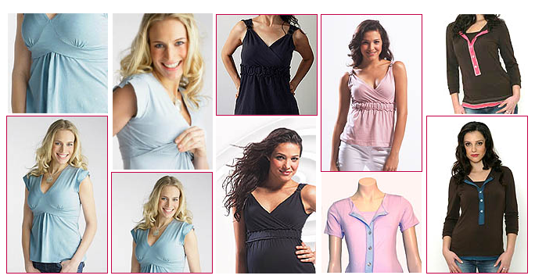
Press Release Body: Take the Fertile Mind's Goddess breastfeeding top available in several colours - perfect for the warmer weather, with cool cap sleeves and a flattering bustline. Another clever designer is Mothers en Vogue who have created the Classic Sleeveless Ruched Top this summer that is feminine and cute in pale pink and flattering black. For those who prefer sleeves, short or three quarter, the Fertile Mind Henley is available a wide range of colours and has the length and stretch in the fabric to also provide a maternity solution as well as breast feeding. Breastfeeding is being well supported by the Australia Breastfeeding Associate and the changes in “Nursing Fashion” give mothers more choice in their decision because they don’t have to wear baggy t-shirts while breastfeeding any more.
Web Site: http://www.fertilemind.com.au/maternity-wear
Contact Details: Fertile Mind Pty Ltd
PO Box 215
Seaforth NSW 2092
Phone: +61 2 9905 0199
Fax: +61 2 9905 0322
www.fertilemind.com.au
sales@fertilemind.com.au
Contact Details: Fertile Mind
6893 Sullivan Road
Grawn MI 49637
Fertilemind@netordering.com
(562) 508 4271
http://www.fertilemind.com

