Estée Lauder Launch New Christmas Gift


Released on: December 6, 2007, 3:18 am
Press Release Author: Brona McCafferty
Industry: Apparel & Fashion
Press Release Summary: Estée Lauder, one of the world's leading manufactures of skin care, cosmetics, and perfume products launch new Christmas Gift Collection
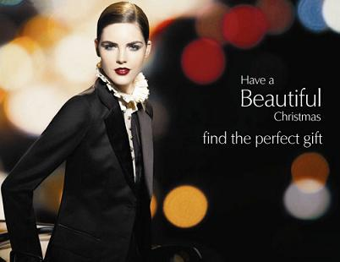
Press Release Body: Estée Lauder, a company recognised for innovation, research and quality, has launched their Christmas Gift Collection.
The Estée Lauder website now offers a special Christmas gift guide, which contains fragrances, makeup and skincare products that visitors can order for girlfriends, wives, mothers daughters, friends and men. The website site has an easy to use interface that allows customers to browse and buy Christmas gift ideas by category, price bracket and recipient.
The site also offers Christmas beauty gift sets, as well as a range of hard to find beauty products such as Lauder For Men, the full Re-Nutriv range, Ideal Matte Makeup and Azurée Pure Fragrance spray. Customers are also able to choose two complimentary gifts from a choice of deluxe samples, with every purchase they make.
There are also several special offers on cosmetics which have been launched to coincide with the launch of the Christmas Gift Collection, including free delivery with purchases over £75 and an option to select free gift wrapping will all purchases throughout the festive period. Estée Lauder uses a premium courier service to ensure goods are not lost in the post, and customers can choose from a number of delivery options including named day delivery, next day delivery and Saturday delivery.
The Estée Lauder site also offers visitors a number of free advice guides from International Makeup Artist’ Alan Pan, including a Skincare regime guide, a foundation application guide, an eye shadow application guide, and a brushes application guide.
About Estée Lauder
In 1946, Estée Lauder started business with one face crème, and the desire to bring out the beauty in every woman. By the time the revolutionary fragrance Youth-Dew was introduced in 1953, the Estée Lauder Company had already won a reputation for innovation, research and quality.
Now Estée Lauder's skincare, makeup and fragrance collections exemplify the best that technology, science and arts can achieve. The Estée Lauder name on a product is recognised in over 100 countries for quality and has gained a worldwide reputation for elegant, and luxurious products that uphold the finest standards of excellence through extensive research and stringent product testing.
The Estée Lauder Companies’ annual Breast Cancer Awareness Campaign involves all of the 18 brands that make up The Estée Lauder Companies. They collectively represent The Breast Cancer Research Foundation’s first and largest corporate supporter. Estée's daughter-in-law was the creator of BCRF's signature pink ribbon. Over $10 million has been raised for The Breast Cancer Research Foundation since 1993. Another $1 million was raised from their retail partners since July 2002.
Web Site: http://www.Estéelauder.co.uk/
Contact Details: PR contact:
Brona McCafferty
73 Grosvenor Street
London
W1K 3BQ
08700346911

