Modern Furniture Trends

Released on: March 25, 2008, 8:03 pm
Press Release Author: LA Furniture Store
Industry: Apparel & Fashion
Press Release Summary: LA Furniture Store features collection of modern furniture, contemporary furniture Press Release Body: Modern Furniture Trends
At this point in time many baby boomers are making the shift from their big homes to smaller condos. This has created a trend of smaller or more ‘space conscious’ furniture that would look neat and comfortable while not occupying too much space. A perfect example of this, is sectional furniture as they can be used together or separately which allows homeowners greater customizability, thereby allowing them to use space very efficiently. In addition to this the demand for easy care fabric have also risen as people, especially baby boomers do not wish to make too much of an effort to maintain the original appearance of their furniture. For this reason a lot of modern furniture is a single, solid color as not only does it look nice but a monotone fabric, especially that of solid color is easier to care for.
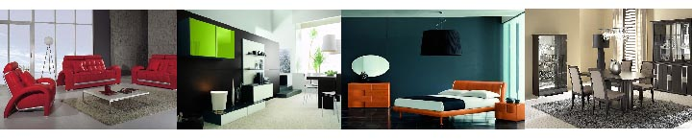
A very prominent contemporary furniture trend is the use of ‘green’ or environmentally friendly products which is a result of the rising awareness of global warming and other such environmental factors. Examples include the use of material that do not emit toxic gases and also do not deplete scare resources. They are also designed to last very long so that they may be conserved for future generations and in addition many are made to be easily recyclable. Many contemporary furniture designers now use reclaimed lumber to craft their products as a result of this trend. Also very versatile furniture is in demand as designers try to get as much use out of a single piece of furniture as they can. One designer has even created a bed that can be instantly converted into a coffee table.
With regard to modern Italian furniture a lot of emphasis is placed on lightness. Lightness in this case is brought about by the use of padding and soft, gentle lines. Designers are also exploring organic shapes that are inspired by animals, plants and nature in general. Folds and cuts or basically geometric designs are another emerging style, and are mainly used in furniture such as tables and bookshelves. The most dominant colors relating to Italian furniture recently, are red, black, and orange.
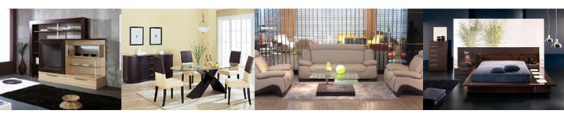
The trend for white living room furniture that used to be popular in the 1980’s is now making a comeback. This time however, the downside of making a room look too ‘sterile’ is negated by the implementation of bold, red or black accents to furniture which give it a more appealing look. With concern to lamps pewter and brushed nickel lamps are now very popular and their subtle look is favored over the intense gleam of chrome. The demand for solid colored furniture that contrasts each other is also on the rise. High contrasts such as red on white or yellow on pink fit into this category. More exotic furniture such as those inspired by Japanese culture is also making its way into living rooms. Zen inspired furniture is one of the most prominent and is fashionable. Moroccan accents and decorative pieces are also well-liked, especially their glass vases and wooden sculptures.
Platforms beds have been very well received in the furniture world as they are very trendy and also quite efficient. They are basically a raised flat surface that does not need a box spring or mattress as its foundation. They not only look very elegant but also do not occupy as much space which makes them great for condos. Some platform beds also come with drawers underneath them which allow it to further maximize the use of space in a room. Many people also like to complement a platform bed with a memory foam mattress. They come in a variety of styles ranging and are made of either metal or wood or both.
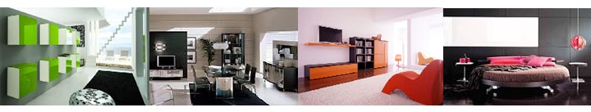
Modern lacquer beds, especially platform ones are also very popular as their high glossy sheen adds an air of elegance and professionalism to the room. The surfaces of these lacquer beds are very durable which allows for easy maintenance while not deducting from the appearance of the bed. Also a trend for lacquer furniture in general is the use of water based lacquers which are much more environmentally friendly as they are less toxic than their solvent based counterparts.
In conclusion, most modern furniture is becoming more environmentally friendly and also drawing a lot of inspiration from nature. Also being as efficient with space as possible is another growing trend, due to the increase in condos and also a sleek and elegant look in general. In relation to colors, solid ones such as red black and white are very popular. As far as exotic furniture is concerned Japanese inspired works seems to be the most favored.
LA Furniture Store
www.lafurniturestore.com
Web Site: http://www.lafurniturestore.com
Contact Details: 3828 Santa Fe
Vernon, CA 90028
info@lafurniturestore.com

