New Website Helps Consumers Make and Personalize Homemade Ice Cream



Released on: March 4, 2008, 1:43 pm
Press Release Author: Wendy Hague
Industry: Internet & Online
Press Release Summary: About All Things Ice Cream

Each year, 1.2 billion gallons of ice cream are manufactured in the U.S. No matter what time of year it is, ice cream is a satisfying and tasty dessert that is loved by children of all ages. This original website provides the consumer with a variety of ice cream making kits, accessories and flavorings for a total ice cream experience.
Press Release Body: “We believe that people want a healthier and personalized option to making ice cream for their family. This website provides an array of ice cream makers and accessories that enables the consumer to control exactly what goes into their ice cream and to customize to taste. Plus, this site provides unique party kits and gift baskets that include quality toppings and flavorings,” said Christopher Homer, President of Knockout Strategies. “We’ve turned making your own ice cream into an experience that is interactive and fun for the whole family,” adds Chris Homer.
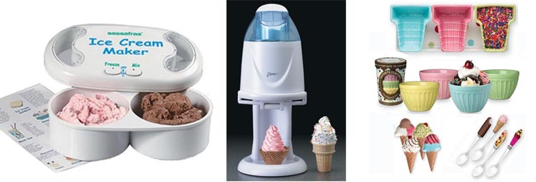
About Knockout Strategies, Inc.
Knockout Strategies, Inc. specializes in direct to consumer advertising. The company has been successful helping clients plan and launch direct to consumer marketing campaigns that span television, radio, web, print, product development and retail.
“There are a lot companies that specialize in manufacturing and distributing ice cream. However, the goal of All Things Ice Cream is to be the ‘DIY’ of homemade ice cream. You can select how you want to make your ice cream, what you want to put in it and how much you want to make. Customers love www.allthingsicecream.com because it’s one-stop-shopping for all their homemade ice cream needs delivered conveniently to their doorstep. You have to check this website out. You’ll be amazed at all the ingenious ways to make ice cream at home,” concludes Chris Homer.

Web Site: http://www.allthingsicecream.com
Contact Details: Contact:
Wendy Hague
All Things Ice Cream.com
Telephone: 207-591-6075 ext. 101
Fax: 207-591-6076
E-Mail: wendyh@knockoutstrategies.com
www.allthingsicecream.com

