Carpal Tunnel Syndrome Treatment by a Los Angeles Hand Surgeon

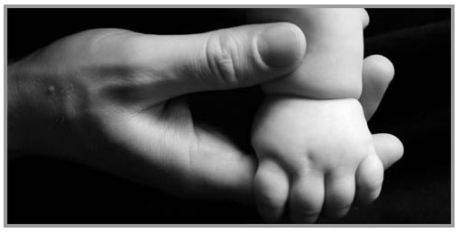
Released on: April 23, 2008, 5:18 pm
Press Release Author: L.A. Hand Surgeon
Industry: Healthcare

Press Release Summary: Los Angeles hand surgeon treats carpal tunnel syndrome and other diseases and injuries to the hands, fingers and wrists in Beverly Hills & West Hills.
Press Release Body: Our hands are in almost constant use and one of the more visually obvious parts of our bodies. In their use, our hands are subject to constant and variable forms of acute or sudden injury such as fractures as well as conditions such as arthritis and carpal tunnel syndrome which result from chronic forms of trauma.
More closely attributed to work conditions, wrist pain, numbness in the fingers and hands, night awakening with numb and painful fingers, and weakness in the fingers are common symptoms of carpal tunnel syndrome, affecting millions of working men and women. Left unchecked, this condition can be debilitating and resulting deficits can become permanent. Carpal tunnel syndrome can often be averted by work modification, use of a splint, rest, use of supplements such as vitamin B6, and possible hand therapy rendered by a specialist. If necessary, a surgical procedure can be performed where the carpal tunnel is released freeing the compressed Median nerve through a small incision. The operation is performed under slight sedation, lasting approximately 20 minutes, and numbness almost completely resolves in most cases after surgery.
Our Beverly Hills and West Hills hand surgeon can provide diagnosis and treatment for all conditions that affect your precious hands to keep them working at their best. We are well experienced with carpal tunnel syndrome, as well as other conditions afflicting the hands. Hand surgeons are highly trained surgeons who have also received additional fellowship training in hand surgery at an accredited university in addition to completing specialty training in plastic surgery or orthopedic surgery. Hand surgeons are trained to address the wide spectrum of conditions affecting the hands and to guide the patient in alleviating them, very often without any need for surgery.

Carpal Tunnel syndrome can appear at any time in life and can have serious consequences on our enjoyment of life. Those who suffer from carpal tunnel syndrome know that any movement of the wrist can be painful and restricted. When even routine, everyday actions produce pain and numbness, it is time to see your Los Angeles hand surgeon to initiate conservative treatments and possible avoid surgery.
Arthritis often shows up later in life or following a fracture or chronic trauma to the wrist, thumb, or any of the fingers. It can often be treated by modifying use of the affected joint or by medication, but arthroscopic surgery can sometimes be used to repair the damaged lining of the affected joints. Our physician at L.A. Hand Surgeon will perform a comprehensive history and physical examination to determine the nature and extent of injury, and suggest possible conservative and surgical remedies which may be available. We work closely with certified hand therapists who will help to guide you back to health. Our goal is to utilize the least invasive treatment regime to arrive at the best medical outcome, achieving a painless and functional state for the hands.
Our dedication to providing excellent patient care is why the L.A. Hand Surgeon receives glowing testimonials from former patients. For any condition from the fingertips to the elbow that requires medical attention, our Beverly Hills office is now open to treat your needs.
Web Site: http://www.lahandsurgeon.com
Contact Details: L.A. Hand Surgeon
9301 Wilshire Boulevard, Suite #401
Beverly Hills, California 90210
(310) 274-3481

