Digital Scrapbooking Community Enthusiastic About New Very Affordable 12"x12" Photobook

Released on: April 3, 2008, 9:56 am
Press Release Author: Viovio, Inc.
Industry: Internet & Online
Press Release Summary: Viovio, an online community and creative publishing service, has responded to customer requests for an affordable 12x12 photobook. Joining the company's existing Photo Book line-up this month are four new square format books: the much anticipated 12x12 Memory Book and two mini book brag books in 5x5 and 3.5x3.5 sizes.
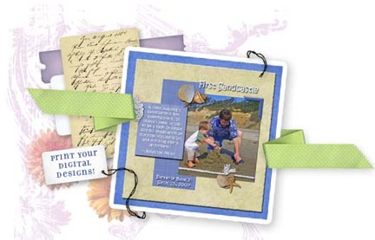
Press Release Body: Raleigh, NC (express-press-release) April 3, 2008 -- Viovio, an online community and creative publishing service, has responded to customer requests for an affordable 12x12 photobook. Joining the company's existing Photo Book line-up this month are four new square format books: the much anticipated 12x12 Memory Book and two mini book brag books in 5x5 and 3.5x3.5 sizes.
"At Viovio we strive to accommodate to our creator's needs. After numerous requests from scrapbook enthusiasts, we decided to introduce the 12x12 photobooks," commented Connie Fowler, Co-Founder of Viovio. "Scrapbooking is a wonderfully growing industry and so many of our users are looking to meet their scrapbooking needs."
The 12x12 is offered in a die-cut hardcover that displays a selected 4x3 digital cover image. The creator has the option to choose from 15 different cover materials in suede, linen, or leather. "Our goal is to offer our customers an extensive array of options when it comes to 'the look' of their photobook," commented Fowler. Pricing is a very affordable $14.99 base cost plus 75 cents per page. So for example, a 40-page book would only cost $44.99.
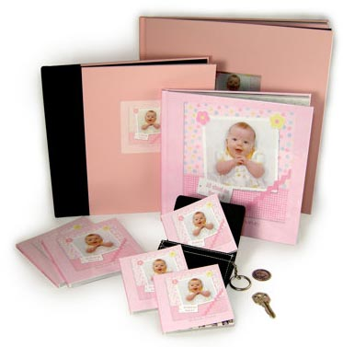
In addition to the new photobooks, Viovio also streamlined the order process for the square format books. All square format books can be uploaded in the 12x12 format, and then Viovio's software will automatically scale them to the size of book you choose at check out. So with one upload you can now order multiple sizes.
How it works:
1. Upload your pictures, individual layouts or completed PDF book to your Viovio gallery.
2. Be certain your images or pages are in the order you wish them to appear in your book and select the "order photobook" option.
3. All square sizes are found under the master page 12x12 page option.
4. Follow the steps in the bookmaker (if you have uploaded individual page layouts be sure to check the "auto crop" option.)
5. Select your cover and book size, and place your order.
For helpful design hints please visit our scrapbooking section. http://www.viovio.com/scrapbooking/
About Viovio (www.viovio.com):
Founded in 2004, Viovio offers a creative and easy-to-use photo publishing service that allows users to upload photos, completed pages or PDF books, create travel blogs, create photobooks, and exchange information about their favorite places and memorable adventures. More than just a publishing Web site, Viovio is an online community designed for photographers (professional and novice), travel enthusiasts, and those who want to combine the two. Viovio's goal is always to produce on-demand products of exceptional quality with record speed without ever compromising quality, customer service or price. The company offers 300 MB of free photo storage, a capacity that can be upgraded.
###
Web Site: http://www.viovio.com
Contact Details: Post Office Box 6087
Raleigh, NC 27608
919-757-2062
marketing@viovio.com

