Waitrose provides chocolate maker Willie with golden ticket


Released on: April 11, 2008, 1:37 am
Press Release Author: Waitrose Limited
Industry: Food & Beverage
Press Release Summary: William Harcourt-Cooze, a self-styled Willy Wonka, lands his golden ticket with top supermarket deal
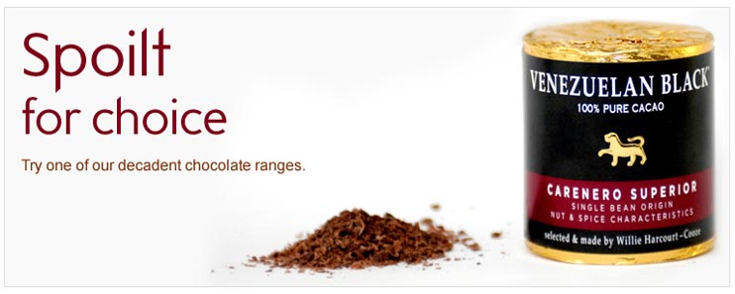
Press Release Body: One man has embarked on the risky mission of turning his obsession with the dark stuff into a livelihood. William Harcourt-Cooze, a self-styled Willy Wonka, is launching what is thought to be the strongest chocolate on sale in any UK supermarket. With 100% cacao content, the chocolate has such a powerful kick that it's more suited for recipes than for nibbling. Willie recommends the use of his chocolate in both sweet and savoury dishes including truffles, chocolate marinated steak and soup.
Willie's unique Venezuelan Black is now hitting the Waitrose shelves after he impressed buyers with his passion and commitment to crafting the ultimate chocolate. Willie's life long quest to find the perfect chocolate and get it onto supermarket shelves is a labour of love that has lasted more than a decade. But his passion for Venezuela goes back even further to a twist of fate nearly 20 years ago when his boat blew up off the coast of the South American country. He instantly fell in love with the country and its chocolate, which is regarded as the world's finest and is prized by chocolate lovers worldwide.
Eleven years ago he purchased his own land in Venezuela and planted 10,000 cacao trees at the Hacienda El Tesoro below the cloud forests of the Henri Pittlier National Park. Soon afterwards he set up a small chocolate factory in Devon and in his search for perfection he even tracked down antique Spanish chocolate making machinery. And with a successful cacao harvest behind him, Willie is finally poised to make his chocolate dream a reality.
"Chocolate is Willie's life and his passion shows in the high quality of Venezuelan Black", said Waitrose Home Baking Buyer, Christopher Moore, "Against all the odds he has come up with a chocolate that takes your breath away. Willie's cacao will inspire cooks to think about using chocolate in a different way. 100% pure cacao is as perfect grated into gravy as it is for making the ultimate chocolate pud. A chocolate with 100% cacao content is something we haven't offered our customers before. The strongest chocolate we currently offer is 85%. Venezuelan Black at 100% cacao certainly packs a punch and isn't for the faint hearted."
Willie said: "Many people who knew me thought this was a madcap scheme, but for me it's a passion and I've never been more serious about anything in my life. I've seen my Bank Manager more often than my wife in the last couple of years. But seeing the results of my labour on the supermarket shelves will be like a dream come true."
Waitrose will be stocking all three cacao bars from Venezuelan Black.
Single estate Hacienda El Tesoro is made with beans farmed at Willie's own plantation. Rio Caribe Superior and Carenero Superior are both from a single bean origin and sourced by Willie during his extensive travels of Venezuela. The chocolate is sold in drum shapes rather than conventional rectangular bars in order to make it easier to grate.
Notes to Editors
Willie's quest to produce the perfect chocolate has been followed by Channel 4 in the documentary Willie's Wonky Chocolate Factory.
About Waitrose
Waitrose is committed to supplying the highest quality food and works in partnership with small producers, supporting British producers where possible to help boost the economy in many rural areas and ensure its customers get to sample the very best foods made locally. Waitrose is committed to working with its suppliers to ensure good working practices throughout its supply chain.
Web Site: http://www.waitrose.com/
Contact Details: For more information contact
Karla Graves
Press Officer, Consumer
Waitrose Limited
Doncastle Road
Bracknell
Berkshire
RG12 8YA
Tel: 01344 82 5204
Fax: 01344 82 5211
www.waitrose.com

