Access Discounts Offers Discounted Residential Lighting

Released on: May 15, 2008, 5:56 pm
Press Release Author: Access Discounts
Industry: Energy
Press Release Summary: Spring savings on bathroom lighting, kitchen lighting & indoor grow lights
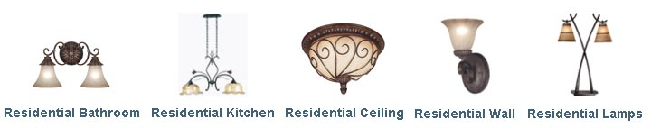
Press Release Body: (Milpitas, CA) May 15, 2008 - www.AccessDiscounts.us - a leading supplier of grow lights, residential lighting and commercial lighting, today announced the newest inventory of quality residential lighting lines, available at deeply discounted prices.
Shoppers can experience significant savings on residential lights including bathroom lighting options, kitchen lights, chandeliers, wall lights, lamps and energy saving lights.
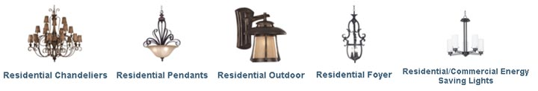
"Spring cleaning is more than organizing and cleaning out the closets. Home owners add value to their homes and prepare for more indoor and outdoor entertaining," stated Christina Roush, spokesperson for Access Discounts. "Spring and summer is the time when less focus is on holiday decorations and more attention on functional enhancements. With the instant savings we offer, shoppers can get more value out of their purchases without experiencing a huge hit on their pocketbooks," Roush concluded.
With a slowing housing economy and stiffer competition, sellers are encouraged to make more enhancements to entice buyers. Landscaping and lighting are economical options that add a lot of impact and perceived value to homes. Replacing outdated lighting with contemporary lights, newer energy saving lights and decorative lighting throughout the home can add significant value for little to moderate investment cost.
Updating residential lighting fixtures offer brighter and lighter solutions, many of which cost less both in purchase price and utility bills. Many of the newer lamps, wall lights, ceiling lights and chandeliers for bathrooms and kitchen are more efficient and provide better maintenance schedules than their older counterparts. AccessDiscounts.us provides 100% American made residential lighting products guaranteed to be of the highest quality.
Access Discounts aims to provide customers efficient, effective and quality residential lighting solutions. By offering precision engineered products meeting ETL, UL & CUL standards, the company brings the very best residential lights to market while passing savings on to their customers. Home owners can take advantage of the price break and implement power saving solutions to their indoor and outdoor environments. For more information on residential lights on sale, please visit http://www.AccessDiscounts.us.
About Access Discounts
AccessDiscounts.us provides a wide selection of grow lights, residential lighting and commercial lighting of the highest quality. Leveraging the close relationships developed with top lighting manufacturers, Access Discounts is able to provide the very best in lighting solutions at affordable prices. As a leading supplier of lighting fixtures for horticultural lighting, indoor and outdoor lighting, Access Discounts strives to bring quality lighting to customers nationwide. Founded in 2002 with headquarters in Milpitas, CA AccessDiscounts.us offers lights, lighting fixtures and accessories for residential, commercial and horticulture lighting needs. For more information, please visit http://www.AccessDiscounts.us.

Web Site: http://www.AccessDiscounts.us
Contact Details: Press Contact
Name: Christina Roush
Title: General Manager
Email: support1@accessdiscounts.com
866-647-0624

