Amber Jewellery | Exclusive Silver Amber Jewelry
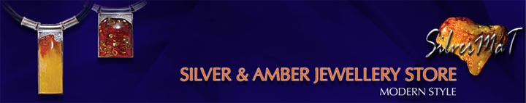

Released on: May 18, 2008, 1:46 am
Press Release Author: SilverMaT Ltd.
Industry: International Trade
Press Release Summary: SilverMaT Ltd. is one of most dynamically developing companies in amber jewellery business. We offer a wide range of silver with amber products as amber bracelets, amber necklaces, amber pendants, amber brooches, amber rings, amber earrings, amber cufflinks, amber set.
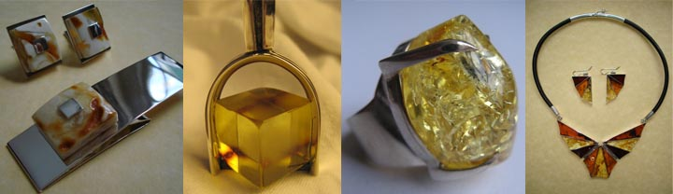
Press Release Body: SilverMaT Ltd. is one of most dynamically developing companies in amber jewellery business. We offer a wide range of silver with amber products as amber bracelets, amber necklaces, amber pendants, amber brooches, amber rings, amber earrings, amber cufflinks, amber set.
All of our amber jewellery products are of very high quality handmade. The natural Baltic Amber we're using is very carefully selected to be possibly the best and the Sterling Silver is the European Standard material called 925 (92.5%) Silver.
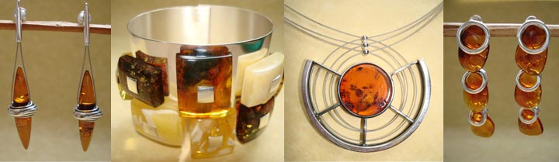
Our Amber Jewellery offer encompasses traditional as well as modern jewellery with big selection of unique patters produced by famous polish designers, excellent specialists in Baltic Amber. High quality of our products constitutes a distinctive feature of a company.
The articles we are supplying are already available in most of West-European countries where they are constantly gaining bigger attention.
Our Amber Jewellery offer applies to people of discerning tastes, people who are willing to participate in the most original trends of the exclusive and modern art.
Web Site: http://www.silver-ambermar.com
Contact Details: 122 Aldermans Hill
London
+442089203590
silvermat@silver-mat.com

