Foreign Translations, Inc., Launches New Interavtive Website


Released on: May 5, 2008, 9:07 am
Press Release Author: Ken Zwerdling - CEO - Foreign Translations, Inc.
Industry: Internet & Online
Press Release Summary: After a year in the making, Foreign Translations, Inc., has launched its new website. The address is still the same (www.foreigntranslations.com) but everything else has changed.
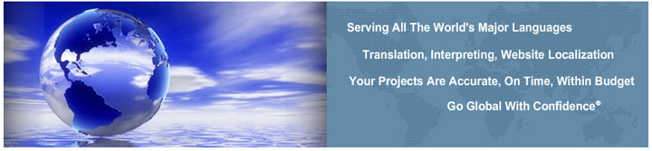
Press Release Body: After a year in the making, Foreign Translations, Inc., has launched its new website. The address is still the same (www.foreigntranslations.com) but everything else has changed. According to CEO, Ken Zwerdling, “The new website is more interactive. It gives you a better understanding of our services and access to free tools that can help companies go global including currency conversion, weights and measures, length and distance, temperature conversion, a global time zone chart and a free translation tool.” The graphics for all the languages and industries were carefully selected in order to give the visitor the feeling of actually being in that particular country. In addition Foreign Translations (www.foreigntranslations.com) has added a strategic partners sections, free whitepapers, client testimonials, expanded views of clients, years of company news and a generous referral program. Foreign Translations helps companies “Go Global with Confidence.”®
About Foreign Translations
Foreign Translations, Inc. (www.foreigntranslations.com) is a 10 year old foreign language translation, interpreting and website localization firm headquartered in Greenville, SC with locations in Atlanta, GA. We translate documents ranging from technical manuals, legal contracts and marketing collateral to financial statements, training manuals, e-learning courses, web sites, medical journals, software, policy and procedure handbooks, newsletters and much more. With over 1,000 native translators located in over 30 countries, Foreign Translations frequently translates documents that range from 1,000 words to over several million in all the major languages of the world. In addition, we can provide interpreters for depositions, trials, sales meetings and conferences in every major city in the United States as well as every major country in the world. Foreign Translations also provides a full range of Multilingual Desktop Publishing Services in any format of any size.
Some of Foreign Translations corporate clients include Computer Associates, Procter & Gamble, Michelin North America, Fuji, Federal Mogul, Fluor Enterprises, Kimberly Clark, UPS, Sunbeam/Jarden, Carrier Corporation, Rockwell Automation, Techtronic Industries, Motorola, Chevron Phillips, Ogilvy Worldwide, L’Oréal Paris and many more. In addition, Foreign Translations hold a General Services Administration Contract ("GSA") with the Federal Government. For more information, visit www.foreigntranslations.com
Web Site: http://www.foreigntranslations.com
Contact Details: Ken Zwerdling - CEO
Foreign Translations, Inc.
55 Beattie Place - Suite 205
Greenville, SC 29601
864-272-0480
translations@foreigntranslations.com

