Red Funnel Holidays launches its 2008 camping packages

Released on: May 14, 2008, 5:40 am
Press Release Author: bgb communications
Industry: Transportation & Logistics
Press Release Summary: Red Funnel Holidays announce launch of latest Ferry inclusive camping packages for 2008
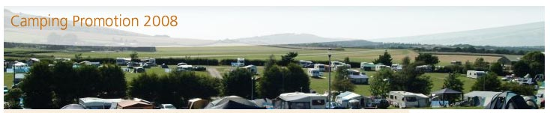
Press Release Body: Red Funnel Holidays, the Isle of Wight specialist, has announced the launch of its new camping and touring breaks programme for 2008.
The new Red Funnel camping and touring packages all include return ferry travel for up to four people together with a vehicle, regardless of whether the vehicle is the size of a mini or a motor home, or has a caravan or a trailer attached. The packages consist of either three-night or five-night stays with a pitch at one of three holiday parks along with return crossings from Southampton to East Cowes on the Isle of Wight.
The special camping promotions are being made available until mid July and then from September through to the New Year.
Campers will be able to choose from one of three holiday parks on the Isle of Wight, each in a fantastic location with attractions nearby, beautiful views, and plenty to entertain the family.
The Orchards Holiday Park is set in the stunning scenery of the west of the Island and is perfectly located for a walking and cycling break. The park is a member of the prestigious Best of British for privately owned touring and holiday parks, and has received seven consecutive David Bellamy Gold Awards for conservation, as well as a Gold “Green Island” Award.
Southland Camping Park on the outskirts of Newchurch has won many awards for its green credentials, as well as MMM’s Best Park for Motorhomes and the prestigious Calor Best Touring Park, England Award. The park is also superbly placed for taking walks amid the island's beautiful landscape.
Whitecliff Bay Holiday Park features its own secluded sandy beach and, with its heated indoor pool, children’s play zone, and crazy golf, is the ideal choice for families.
Red Funnel Holidays will be offering anyone who books one of the new camping promotion packages a 10% discount voucher, redeemable on any purchase in Towsure’s Southampton store. Towsure is the UK’s largest towing and outdoor leisure company and with the Southampton store just a short drive from the Red Funnel mainland terminal, the voucher will make it easy for travelers to pick up last minute supplies before heading off to the Isle of Wight by ferry.
-ends-
Web Site: http://www2.redfunnel.co.uk/
Contact Details:
For further press information contact:
Lisa Baum
Junior Account Executive
bgb communications
Capital Tower
91 Waterloo Road
London
SE1 8RT
020 7902 2951
www.redfunnel.co.uk/camping

