Topman announces the arrival of the new mens spring collection


Released on: May 29, 2008, 8:26 am
Press Release Author: Topman
Industry: Apparel & Fashion
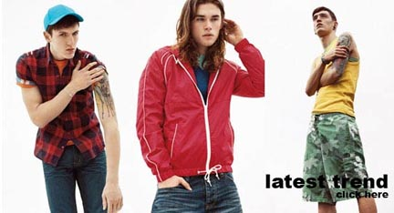
Press Release Summary: Topman, the U.K’s leading mens clothing retailer has announced the arrival of their new spring collection
Press Release Body: Topman, the U.K’s leading men's clothing retailer has announced the arrival of their latest spring collection, featuring new ranges of classic ‘must have’ sunglasses and jeans and the latest in fashion design.
Fashion conscience men across the country searching for the latest look this spring will be able to find a huge range of mens clothing online in the new collection from Topman, including cardigans and Y-neck tops, as well as accessories such as attention grabbing belts, retro bags and a selection of brightly coloured T-shirts and vests, in a variety of individual styles and patterns.
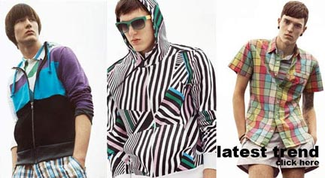
Adding to the exciting cutting edge designs in this season's collection Topman has launched the “The Classic Sunglasses” project in conjunction with Linda Farrow. Following on from last season’s White Shirt Project, this will be the second in a series of designer collaborations with Topman. This particular project sees Linda Farrow adding a contemporary touch to already classic styles of sunglasses including the perennially popular Aviator and Wayfarer styles of eyewear. This season will see designers such as Bernhard Willheim, Kim Jones, Oliver Spencer and 0044 all producing brand new and innovative looks in conjunction with Topman.
The latest mens fashion trends from Topman takes inspiration from the Interwar Oxbridge days. In a time which heralded the growth of film and fashion photography, the prosperous youths became more fashion conscious with the exposure to Hollywood glamour. Look out for wider length trousers, draw string waists, longer cardigans, linen shirts and a range of patterns and designs for a looser yet smarter, more relaxed silhouette for the spring season.
Jeans have been a staple of mens fashion for quite some time and they remain in vogue this spring, with Topman featuring a full range of styles online. Bootcut and worker jeans can offer a comfortable and laid back look to any outfit while a pair of twister or skinny mens jeans add a contemporary and sleek feel and, when topped off with one of Topman’s fitted skinny T-shirts, anyone can have an instant fashionable spring outfit.
About Topman
Topman offers the latest in mens fashion, encompassing a range of styles to suit every shopper. Topman's extensive collection embraces everything from the latest fashion trends to classic pieces, and extends to footwear, accessories and formal wear. Topman also provide the simplest way to search for and buy men's clothing, placing it among the leading fashion retailers in the UK market today.
Web Site: http://www.topman.com/
Contact Details: PR contact:
Gemma Boner
Colegrave House
70 Berners Street
London
W1T 3NL
020 7636 8040
www.topman.com

