Use of Knee Braces in Comprehensive Knee Rehabilitation & Knee Pain Management


Released on: May 11, 2008 11:55 am
Press Release Author: Dr. Brace Company
Industry: Healthcare
Press Release Summary: Have you injured your knee? Need help? A well designed knee brace can be the solution for a person that has injured their knee, had surgery, or for someone that has overall knee pain. Check us out online at http://www.drbraceco.com. We can help you get moving again!
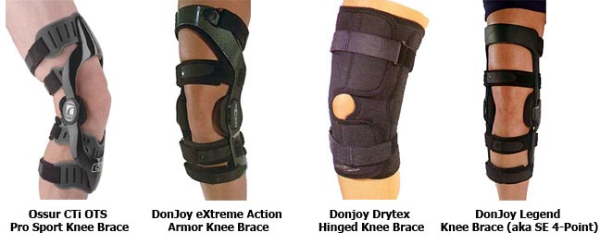
Press Release Body: The knee is the largest joint in the body. The knee joint has an exposed position and as a result many injuries can occur at this part of your body. Whether it is during day-to-day activities, routine athletic performance, or when an individual is participating in extreme sports, a knee injury is a very commonplace phenomenon among musculoskeletal injuries.
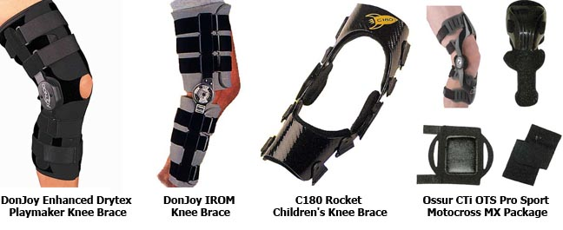
One helpful solution is the use of knee braces. Professionally refered to as a "knee orthosis" (orthosis is a fancy word for external support), these supports are fast emerging as highly effective preventive and therapeutic adjuncts for management of knee injury and knee rehabilitation. Many of us have seen the use of knee braces by high profile athletes, such as Michael Jordan or other college athletes, for example. As a result, the use of knee braces has never been more important that they are now, and can help to provide the support you need to take on lifes physical challenges.
Dr. Brace Company has helped many people find the right knee brace, or other functional brace for different parts of the body. We like to say we brace everything but your teeth!
Don't just buy a brace from an online salesman, check us out online at http://www.drbraceco.com. We are American Board Certified brace professionals.

Web Site: http://www.drbraceco.com
Contact Details: Contact us at support.drbrace@gmail.com with any questions.

