Clear Property Investment unveils new web site and expansion plans
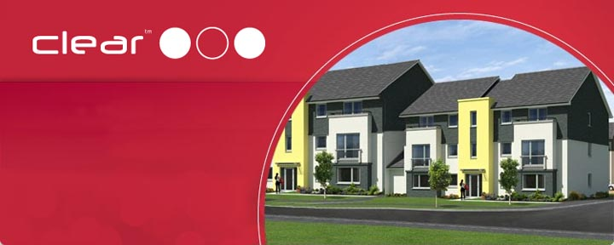
Released on: June 13, 2008, 3:19 am
Press Release Author: Clear Property Investment
Industry: Real Estate
Press Release Summary: Clear Property Investment, an industry leader in buy-to-let property investment, unveil new website and plans to expand their business onto the high street
Press Release Body: Clear Property Investment launch their brand new website, designed to ease the process of buying investment property for thousands of people across the UK.
The new website is the first move in a series of expansions for the company, with Clear Property Investment also announcing plans to open ten high street stores. The new moves are intended to offer investors increased opportunities for lettings and property investment in Scotland without the stress that would normally go hand in hand with such a daunting process.
Clear Property Investment, currently offering prime location property investment in Glasgow, Paisley and Edinburgh, has targeted Scotland as providing some of the best opportunities for potential investment in the present climate. With lively cities and a thriving economy, Clear Property Investment believe many prime Scottish locations have not felt the brunt of the unstable property market which is affecting most towns and cities across the UK, with prices in many areas continuing to rise while once hugely desirable locations like London have seen a large drop in housing prices.
Guiding potential investors every step of the way through the buy to let process, Clear Property Investment have guaranteed a return of 15% yield over two years and, at a time when many lenders can only offer funding for 70% of the purchase price, Clear Property are able to offer customers funding for 85% of the price of the property. In addition, potential investors can save £9000 on properties in Edinburgh and Glasgow, as Clear Property is also providing a full furniture pack for each property sold.
Additionally, Clear Property Investment has announced that it is also preparing to make available property investment options in offshore markets, with commercial properties in destinations like the United Arab Emirates soon to be available. With a history of meticulous customer service and only offering investment opportunities in properties that offer growth potential and high rental yields, the company is hoping to make quite an impact in the offshore property market in the next few years.
About Clear Property Investment:
Clear Property Investment is a property investment company with solutions for people who want the benefits of owning buy to let homes, without the worries, hassles and pitfalls often involved. Clear Property Investment has developed a unique property investment service, based on an extensive knowledge of the property market and experience as property investment and letting agents. This knowledge enables Clear Property to ensure the right property is selected to bring the best return on the customers' investments.
The survey and purchase of the investment property is arranged on the client’s behalf and two years' rental income (at 15% of the purchase price) is guaranteed upon the purchase of the property. Clear Property Investment offers a complete, hassle free property furnishing solution at no cost to the potential investor and a range of possible options are made available at the completion of two years property investment.
Web Site: http://www.investorreadyproperty.com/
Contact Details: PR Contact:
Tahar Ali
Clear Property Investment Partner
272 Bath Street
Glasgow
G2 4JR
(0141) 353 9447
www.investorreadyproperty.com

