Gem Fashion Launch New Affiliate Scheme
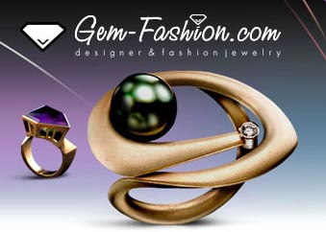

Released on: June 21, 2008, 5:28 pm
Press Release Author: Gem Fashion
Industry: Apparel & Fashion
Press Release Summary: Earlier in the week, leading fashion jewellery retailer gem-fashion announced that they would be implementing a new affiliate marketing scheme. In the world of internet marketing, affiliate schemes have become big business, with large percentages of yearly revenue generated through sales leads in this fashion for many leading on-line retailers.
Press Release Body: The new gem-fashion affiliate scheme is targeted at people who already have a website that is related to fashion or beauty. It will allow these sites to set up links to gem-fashion or even gem-fashion products upon their pages easily. The website will earn 7% in commission for every successful sale that takes place through their link.
The website team at gem-fashion has been briefed to help new affiliates by creating ads that will work best for the affiliate’s site. They are also offering the creation of a full page article or sales letter, which will include pictures of the actual products on sale, for any affiliates who may require them.
Affiliates will also have access to the gem-fashion promotions, which their current customers already enjoy. Becoming an affiliate is a sensible option for related websites, considering the 20% increase on internet based jewellery sales over the last two years.
The gem-fashion business development team has chose ClixGalore to manage their affiliate scheme. This world leader of managed affiliate marketing programs offers a feature rich solution for both the scheme owner and the affiliate members. Full on-line reporting is available along with link tracking, commissions are calculated monthly.
It comes as no surprise to discover that gem-fashion has chosen to launch an affiliate marketing scheme at this time. If we consider the new customer management system that was rolled out earlier in the month, alongside the fact that they have been forging solid relationships with major fashion jewellery manufacturers, then the launch of this kind of scheme was surely inevitable.
This is a wise business decision, and gem-fashion has proven time and time again that they are the kind of organisation that is willing to make changes to improve their business. We can only expect to see them going from strength to strength once the effects of this new affiliate marketing scheme begin to show. Already they have a firm customer base, re-enforced by the high quality on-line fashion magazine they provided as added value. By exploiting yet another source of sales leads they are positioning themselves to cover every angle within the difficult on-line retails sector they inhabit. Once again gem-fashion proves they have the ability to adapt to the every changing world if internet based business, whilst maintaining their credibility as a major leader in the on-line fashion jewellery market.
Web Site: http://gem-fashion.com
Contact Details: Gem Fashion
225 Foster Ave.
Brooklyn NY 11230
Phone: 1-866-638-3275
info @ gem-fashion.com

