Gladstone's Beautiful Fine Jewellery Set to Shine at IJL 2008
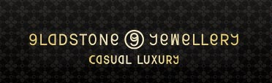

Released on: June 11, 2008, 10:37 am
Press Release Author: Gladstone Jewellery
Industry: Apparel & Fashion
Press Release Summary: Gladstone Jewellery are delighted to announce that they will be primary exhibitors at IJL (International Jewellery London) 2008 and will be showing off their luxurious jewellery collections for everyone to see.
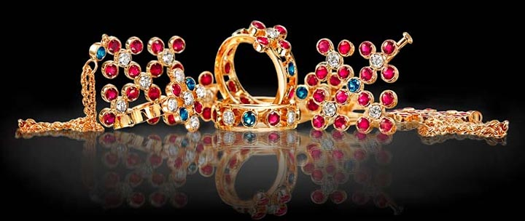
Press Release Body: London, UK, 12 June 2008: IJL is the UK’s only dedicated trade jewellery event, featuring the most talented and innovative British jewellery designers. The stunning and luxury jewellery collections are hand selected to create a truly inspiring showcase of contemporary and classic jewellery.
Taking place from 31st August till 3rd September at Earls Court in London, IJL’s show promises to be an event not to miss for genuine jewellery lovers. Gladstone Jewellery have confirmed that they will be exhibiting their collections of luxury jewellery at the show for the very first time.
The glamorous collections of rings, chokers, brooches, necklaces and bracelets are inspired by the lavish extravagance and splendour that medieval royalty lived in, but are designed for the modern woman to enjoy the fine jewellery in comfort.
Thanks to the unique, patented and eye-catching designs along with the level of craftsmanship and superior quality of their precious stones (diamonds, sapphires rubies and emeralds), Gladstone have been tipped by several fashion industry insiders to shine at the show and to become one of the leading luxury jewellery brands throughout the next few years.
Maria Kunin, Gladstone’s Senior Designer comments: “Gladstone Jewellery are delighted to be exhibiting our fine jewellery collections at IJL 2008, and hope that the added exposure that being featured prominently in ‘The Boulevard’ section of the fine jewellery showcase will bring Gladstone as a brand to the forefront of the fashion and jewellery industries. Gladstone Jewellery is also proud to be sponsoring the main bar at IJL 2008”.
Passionate about beautifully crafted fine jewellery? Gladstone would love to meet you at the show. Gladstone Jewellery can be found at stand E330 in ‘The Boulevard’ (central gallery) of the ‘Fine Jewellery’ section.
Or alternatively, visit Gladstone’s brand new website and online fine jewellery store here: http://www.gladstonejewellery.com
Web Site: http://www.gladstonejewellery.com
Contact Details: Gladstone Jewellery
3 Stanhope Mews East,
South Kensington,
London SW7 5QU
Phone: +44 (0) 845 555 7707
Fax: +44 (0) 208 736 0502
marketing@gladstonejewellery.com

