Many dentists call themselves extreme makeover dentists. What does this mean? What does it take to be an extreme makeover dentist?
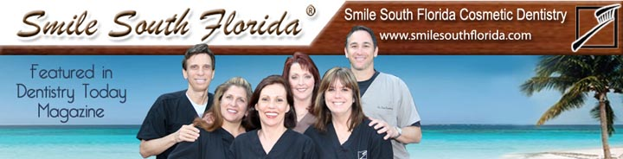
Released on: June 5, 2008, 6:13 am
Press Release Author: Smile South Florida Cosmetic Dentistry
Industry: Healthcare
Press Release Summary: South Florida's Extreme Makeover Dentist, Dr. Nottingham, has the experience, education, & da vinci's endorsement to be counted among the great dentists.
Press Release Body: Many dentists call themselves extreme makeover dentists. What does this mean? What does it take to be an extreme makeover dentist?
Certainly, the dentists appearing on ABC's Extreme Makeover are talented dentists that likely have this advanced dental capability. But, how are they qualified? Who ascertains their ability as a dentist... producers or filmmakers? How about the dental lab service of ABC's Extreme Makeover, da vinci labs? The owners of da vinci dental laboratory had the ability to send their mother to any of the television extreme makeover dentists, but they did not. They chose a talented South Florida dentist, Dr. Charles Nottingham. The Extreme Makeover Dental Lab said the following about Dr. Nottingham:
"...your preparations and impressions exceed perfection [for our Mother]... If the Extreme Makeover show was filmed in Florida, I am sure you would be the providing dentist." [Click here to view the entire testimonial]
I believe this is a very high standard and certainly puts Dr. Nottingham in the same category as the extreme makeover dentists on television. Besides performing the restorative dental work for da vinci's mother, Dr. Nottingham has treated heads of state, professional athletes, business professionals, and even foster children. Dr. Nottingham graduated New York University (NYU) Dental School and obtained a fellowship from the Academy of General Dentistry. Shortly after graduating dental school, Dr. Nottingham completed his post graduate training at the Pankey Institute. Dr. Nottingham is the lead cosmetic dentist for Smile South Florida Cosmetic Dentistry. He continues to raise the standards of dental care for himself, his staff, and the entire dental community. Smile South Florida's mission is to be the number #1 dental practice in South Florida with respect to quality and service. The best way to judge whether a dentist really meets the level of an extreme makeover dentist, rather than just provide the title, is look at the dentist's before and after photographs. Dr. Nottingham's cases have been featured in Dentistry Today and Contemporary Esthetics. Here are the featured cases:
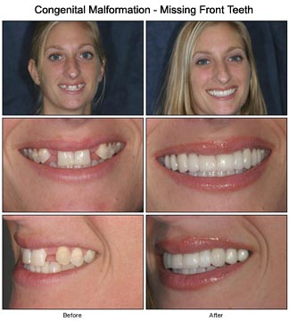 |  | 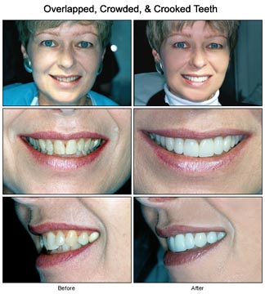
In conclusion, an extreme makeover dentist is one who has an advanced level of dental education and experience, third party accolades and accomplishments, and beautiful before and after photos.
Web Site: http://www.smilesouthflorida.com
Contact Details:
Broward County Office
7401 N. University Dr., Ste. 207
Tamarac, FL 33321
Tel: (954) 721-6950
Fax: (954) 726-4292
Click here for a Map
Boca Raton Office
7301-A W. Palmetto Pk Rd. #303-C
Boca Raton, FL 33433
Tel: (561) 347-7757
Fax: (954) 726-4292
Click here for a Map

