New Historical Fiction Novel: Edith and the Mysterious Stranger
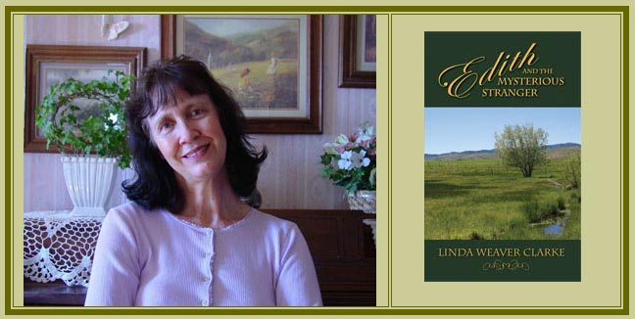

Released on: June 3, 2008, 12:35 pm
Press Release Author: American Book Publishing
Industry: Entertainment
Press Release Summary: Enter the world of Make Believe with Edith and the Mysterious Stranger (ISBN: 978-1-58982-469-0), a historical/fiction novel, filled with adventure and romance.
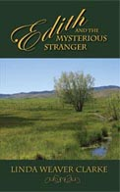
Press Release Body: Enter the world of Make Believe with Edith and the Mysterious Stranger (ISBN: 978-1-58982-469-0), a historical/fiction novel, filled with adventure and romance. With mysterious letters, cattle rustlers, a spunky woman, the liar's fire, Halloween, and young love, there is always something happening.
Melynda Gascoyne, The Amherst Bee Newspaper: Buffalo, New York, wrote: “Clarke draws the reader into a world full of color and intrigue right from the first page. Her characters have faults that you want to see them overcome as you laugh, cry and cheer at just how genuine and vivid they are. They could easily be the neighbor next door. It’s refreshing to be able to read a story that can make you run the full range of emotions. The end is uplifting. I thoroughly enjoyed it. I would highly recommend Edith and the Mysterious Stranger to anyone looking for a novel that is easy to read and just makes you feel good.”
It is 1904. Edith has wonderful qualities but her expectations are so high that she never gives a man a second chance. She used to sing professionally but has now settled down and serves others through her nursing abilities. During her stay in Idaho, Edith meets two men. Henry, the superintendent of schools, seems to be arrogant, flirtatious, and quite impressed with her talents. Joseph, a farmer and ranch hand, is just the opposite. He acts completely disinterested in her and unimpressed. At first, both men tend to get on her nerves until she decides it’s about time to not be so judgmental.

Lisa Haselton, Allbooks Reviews, wrote: “Clarke’s passion for her historical subject matter is apparent in the solid writing, which transports the reader back in time effortlessly. Her multi-layered characters are unique individuals who evoke empathy. The experiences, challenges, dialogue, and dress are realistic for the time period and the descriptions are so vivid the reader is more a participant in the events than a pageturner. Edith and the Mysterious Stranger is a highly recommended read. It’s a great adventure story with strong values; great for the entire family.”
After Edith's arrival to Idaho, a mysterious stranger begins to write to her, which changes her outlook on life for the better. For the first time, she gets to know a man's inner soul before making any harsh judgments. Whoever he is, this man is a mystery and the best thing that has ever happened to her. The question that puzzles her is whether or not he's as wonderful in person as he is in his letters.
Wendy Cleveland, Reader Views, wrote: “The Power of the Written Word -- this is the life lesson I took away from Linda Weaver Clarke’s book Edith and the Mysterious Stranger. I would definitely recommend this to anyone interested in a good inspirational read from beginning to end. You won’t be disappointed. I’m definitely a fan and will be looking for another installment in the Roberts family saga.”
To learn more about Clarke’s books, visit: http://www.lindaweaverclarke.com.
Web Site: http://www.lindaweaverclarke.com
Contact Details: Edith and the Mysterious Stranger:
http://www.pdbookstore.com/comfiles/pages/LindaWeaverClarke4.shtml

