Podcamp Ohio Conference Offers Free Sessions on Podcasting, Blogging and New Media
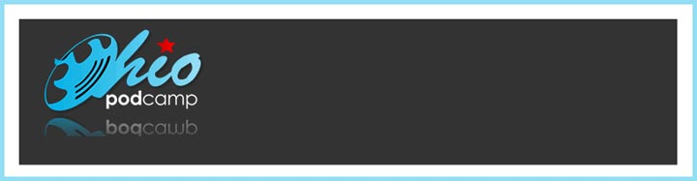
Released on: June 11, 2008, 1:37 pm
Press Release Author: PodCamp Ohio
Industry: Media
Press Release Summary: Podcasters, bloggers and anyone interested in learning more about the world of online social networking and media will be participating in a day-long "unconference" on Saturday, June 28, 2008 at ITT Technical Institute in Hilliard, Ohio.
Press Release Body: (Columbus, Ohio) Podcasters, bloggers and anyone interested in learning more about the world of online social networking and media will be participating in a day-long "unconference" on Saturday, June 28, 2008 at ITT Technical Institute in Hilliard, Ohio.
Participants will be both leading and attending over 20 sessions on various topics, including the basics of podcasting, how podcasting can be used in corporate environments, blog and web site search engine optimization techniques, and how to use social media as marketing tools. There will also be sessions dealing with online etiquette advice, issues of women and new media, and tools and tricks of the website trade. Other sessions and discussions will cover using specific sites like Facebook, MySpace, LinkedIn, Flickr and Twitter. In addition to these sessions, attendees will have the opportunity to socialize, network, and share information about podcasts, blogs, digital music, web video and other new media topics.
PodCamp, first launched in Boston in September of 2006 by Chris Brogan and Christpher S. Penn, have spread to various US and international cities and have helped to build a stronger community of podcasters, bloggers, and other new media enthusiasts. Experience with podcasting or blogging are not requirements to participate; professionals of any industry, hobbyists and students are encouraged to attend.
PodCamp Ohio is presented by ITT Technical Institute in Hilliard (Columbus metro), Blubrry Podcasting Community, and other local new media companies and individuals.
To register for free and to learn more, visit the event's web site at www.podcampohio.com. If you are interested in sponsoring PodCamp Ohio or have any questions, contact Angelo Mandato by calling (614) 429-4474 or sending an email to angelo@podcampohio.com.
Web Site: http://www.podcampohio.com
Contact Details: Angelo Mandato
Organizer, PodCamp Ohio
(614) 429-4474
Email: angelo@podcampohio.com
Web site: www.podcampohio.com

