Signature Golf Packages, Inc. is proud to announce their new golf destination in Las Vegas, Nevada
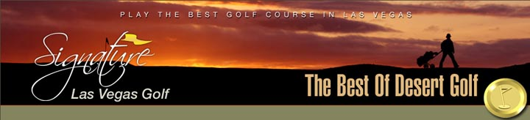

Released on: June 9, 2008, 12:43 pm
Press Release Author: Signature Golf Packages
Industry: Entertainment
Press Release Summary: Signature Golf Las Vegas has a collection of over 20 courses from such great designers as Jack Nicklaus and Arnold Palmer
Press Release Body: Signature Golf Packages, Inc. is proud to announce their new golf destination in Las Vegas, Nevada. Signature Golf Las Vegas has a collection of over 20 courses from such great designers as Jack Nicklaus and Arnold Palmer.
We are excited to be affiliated with Sonoran Suites and their beautiful two and three bedroom condos located just minutes west of the Las Vegas Strip. Visit www.signaturelasvegasgolf.com for more information on golf tee times and golf packages.
Summer is in “full swing” on the Grand Strand in Myrtle Beach. We have some great summer rates as well as fall specials for your group or family.
For more information, on Signature Golf Packages, please contact us at 1-866-462-9885 or visit www. signaturegolfpackages.com. Let us put our “Signature” on your next Myrtle Beach golf vacation.
Web Site: http://www.signaturelasvegasgolf.com
Contact Details: Signature Golf Packages
9480 Indigo Club Drive
Murrells Inlet, SC 29576
Toll Free: 866-462-9885
Local: 843-650-2069
FAX: 843-650-1935

