Smile South Florida Cosmetic Dentistry Launches Its Dental Blog

Released on: June 13, 2008, 9:22 am
Press Release Author: Smile South Florida Cosmetic Dentistry
Industry: Healthcare
Press Release Summary: Smile South Florida Cosmetic Dentistry's Dental Blog is a resource for visitors local and abroad by providing fresh new dental content and practice updates.
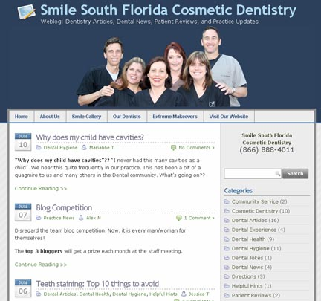
Press Release Body: Smile South Florida Cosmetic Dentistry is announcing the launch of its Dental Blog. This new blog is designed to provide visitors fresh posts on a variety of dental topics.
Blogs are online content management systems that allow organizations to provide visitors specialized content about a range of topics. This dental blog is meant to service the world, but focus more specifically on the Fort Lauderdale, Boca Raton, and Miami patients. In addition to providing dental articles and postings, the Smile South Florida blog will have practice updates. This provides patients with a richer experience.
Whether a visitor is looking to find the similarities and differences between Lumineers and veneers or is interested in practice news, such as a staff member having a baby boy, the Smile South Florida blog is a place of interesting content and a warm environment.
For more information about the cosmetic dentistry dental posts on the Smile South Florida Blog, you can visit the blog:
http://www.smilesouthflorida.com/blog
To learn more about the dental practice or schedule an appointment, visit the practice website:
http://www.smilesouthflorida.com

About Smile South Florida Cosmetic Dentistry
The dentists at Smile South Florida Cosmetic Dentistry have offices in Broward County and Boca Raton and serve patients from Boca Raton to Fort Lauderdale and Miami. The dentists specialize in porcelain veneers, dental implants, extreme makeovers, Invisalign, and sedation dentistry.
Web Site: http://www.smilesouthflorida.com
Contact Details:
Broward County Office
7401 N. University Dr., Ste. 207
Tamarac, FL 33321
Tel: (954) 721-6950
Fax: (954) 726-4292
info@smilesouthflorida.com
Click here for a Map
Boca Raton Office
7301-A W. Palmetto Pk Rd. #303-C
Boca Raton, FL 33433
Tel: (561) 347-7757
Fax: (954) 726-4292
Click here for a Map

