Guarantee Profits shows Real Estate Investors How to Go Green
Released on: July 8, 2008, 8:50 am
Press Release Author: Gabriella Sannino
Industry: Real Estate
Press Release Summary: Alexandria VA—Saturday July 26th, 2008 9:00 am-4:30 pm Creative real estate solutions of Real Estate Mentor Minh Pham brings Green to the World.
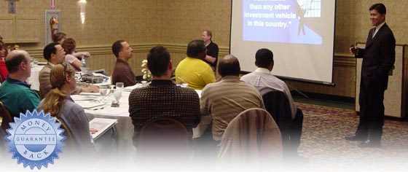
Press Release Body: If you are interested in real estate investing as a real estate developer or as an individual real estate investor seeking the dynamic methods that guarantee profits in the lucrative field of real estate, then you have come to the right place!
There is no one else teaching anything like renowned Real Estate Guru Minh Pham. He will share his proven creative real estate expertise for making money and producing starting real estate investment opportunities in green building, foreclosures, and commercial real estate.
Many real estate investors and real estate developers are confused by the growing popularity among real estate buyers for green buildings or environmentally friendly real estate opportunities. In his free one day real estate seminar, “Hot Trends in Investment, Foreclosure Deals, and Green Building,” Minh Pham prepares you to promote and market green properties to make the most money off of your real estate investment.
By attending the free one day “Hot Trends in Investment, Foreclosure Deals, and Green Building” real estate investment seminar, you will be able to interact and learn directly with nationally known real estate expert Minh Pham. Here are a few of the topics:
• | Why green buildings are vital real estate opportunities for real estate sales agents, real estate developers, and real estate investors.
• | The smart way to create acquisition opportunities for green buildings and environmentally friendly foreclosures.
• | How to close the deal faster and more efficiently with buyers seeking green buildings while by anticipating their objections.
• | Expert methodologies and tools for empowering sellers of eco-friendly buildings and green properties.
If you are seeking the way to Go Green and Get Rich, then you have to be at the “Hot Trends in Investment, Foreclosure Deals, and Green Building” with Minh Pham to master his stellar strategies to guarantee profits and make money in through real estate.
There is ONE catch: Seating is extremely limited and you must sign up for the free “Hot Trends in Investment, Foreclosure Deals, and Green Building” real estate sales seminar today!
To meet attendee demands, Minh Pham moved the “Hot Trends in Investment, Foreclosure Deals, and Green Building” real estate training to a larger conference room. Hurry and take advantage of one of the 10 seats left in the “Hot Trends in Investment, Foreclosure Deals, and Green Building” real estate seminar with acclaimed real estate mentor Minh Pham before they are gone. You can’t afford to miss this!
***Seating is EXTREMELY Limited***
Web Site: http://events.guaranteeprofits.com/
Contact Details: When: Saturday, July 26, 2008 9:00 - 4:30 PM
Where: Keller Williams Kingstowne, 6354 Walker Lane Suite 100. Alexandria VA 22310
To attend this FREE event you must r.s.v.p. by calling (888) 834-6873 or e-mail Info@GuaranteeProfits.com
For more information you may go to http://events.guaranteeprofits.com/

