Introducing Fresh on the scene! Style with a twist,Fresh Phenom T-Shirt and Apparel Line!
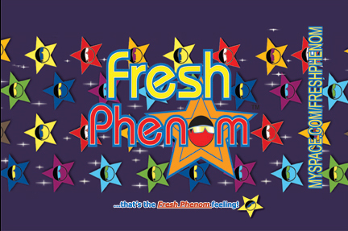
Released on: July 15, 2008, 10:07 pm
Press Release Author: Natasha Pierre
Industry: Apparel & Fashion
Press Release Summary: Fresh Phenom embodies greatness. In order to achieve greatness you must first feel great. Whether you are new on the scene and month after month or year after year of dreaming and overcoming adversity by persevering, you now have achieved your goal. All eyes are on you!Or after years at your current position just when everyone thought your best days were behind you; you thought otherwise, reinvented yourself, and proved to yourself and others you still have greatness in you. That's probably the greatest feeling you've ever had; that's the Fresh Phenom feeling.
Press Release Body: New York, NY -. Oscar Caba and Ralphy Simet founded Fresh Phenom in 2008 to produce and market the Fresh Phenom line of t-shirts and apparel to the fashion industry. Fresh Phenom t-shirts were created and designed to capture the spirit of the “fresh face on the scene,” whether the actor getting all the buzz in Hollywood or the latest first draft pick in the NFL. The t-shirts sport the artwork and logo of the Fresh Phenom, designed by both Oscar Caba and Ralphy Simet specifically for Fresh Phenom. T-shirts are available in men’s sizes, but can certainly be worn by anyone who wants to give off the Fresh Phenom vibe, male or female. Later, the line will expand to offer clothing for both sexes. The t-shirts will be available via the Fresh Phenom web site (www.FreshPhenom.com) and in select retailers (to be announced).
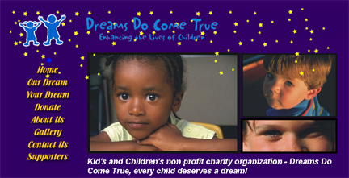
“Fresh Phenom is that feeling you get when you encounter someone who you just know is bound for greatness,” said Fresh Phenom CEO/Co-Founder, Oscar Caba. “It doesn’t have to be someone famous. It could be anyone that has that something to make you sit up and take notice. That’s what Fresh Phenom is all about.”
Fresh Phenom is not just about the up and coming fresh faces but giving back as well. The company will donate a percentage of all sales to Dreams Do Come True, an organization that grants dreams for kids aged 5 to 18 years of age, regardless of their sex, race, financial status or physical wellness.
“Dreams Do Come True is a charity that makes a difference one kid at a time,” said Oscar Caba. “It really captures the spirit that I want Fresh Phenom to embody.”
More information about Dreams Do Come True can be found at www.DreamsDoComeTrue.org.
About Fresh Phenom
CEO Oscar Caba and COO Ralphy Simet, to bring to life the Fresh Phenom movement and introduce the fresh line to the fashion world and it’s admirers.
Please visit www.myspace.com/FreshPhenom for more information.
For media kit and press inquiries, please contact Natasha Pierre directly at 678-625-8640 or email at natasha@abstract-mediagroup.com
Web Site: http://www.freshphenom.com
Contact Details: Abstract Media Group; Natasha Pierre
(P) 678.625.8640 (F) 678.625.9243
natasha@abstract-mediagroup.com

