Love the Years, Erase the Lines – Perfective Ceuticals Anti-aging Miracle
Released on: July 28, 2008, 5:45 am
Press Release Author: Stacy Gramm
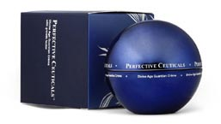
Industry: Healthcare
Press Release Summary: Perfective Ceuticals™ Divine Age Guardian Creme - A new ground in anti-aging skin care utilizing a powerful synergistic combination of Growth Factors with ancient Aboriginal Emu Oil techniques.
Press Release Body: The pursuit of the perfect complexion is a perpetual aspiration for women of all ages.
To realize the perfect complexion, you need a lineless, even-toned epidermis, a resilient dermis and the hypodermis needs enough collagen and elastin to facilitate elasticity and firmness throughout the layers of the skin.
If any part of this triad is deficient, the first signs of aging will appear.
Perfective Ceuticals, the prestigious brand for anti-aging skin care treatments, takes holistic wisdom to compliment the most advance skin care science in focused of every aspect of skin aging.
Perfective Ceuticals™ Divine Age Guardian Crème utilizes a powerful synergistic combination of Growth Factors, based on extensive scientific research, to rejuvenate skin at its various levels; stimulating the synthesis of Collagen, Elastin, and other key constituents of the skin matrix.
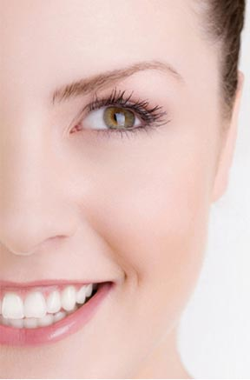
For thousands of years, Emu oil has been used by Aboriginals to heal and calm the skin against the harsh winds and burning sun of the outback. The marriage of ancient Aboriginal Emu Oil techniques and the most advanced Growth Factors complex, interact in a complementary manner to reverse skin aging both intrinsically and extrinsically, achieving optimal results in any skin complexion.
This union of traditional and cutting edge cosmetic expertise facilitated the creation of the breakthrough formula to provide an all-in-one solution for the deterioration of appearance.
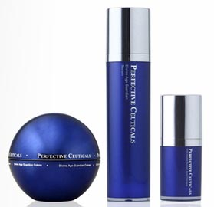
Elaine Graham, a make-up artist for fashion magazines, said "I've been using almost everything anti-ageing products in the market and now I realized how much money I had wasted over the years on inferior products. I did not start out with bad skin. However, after about 4 weeks of consistently using Perfective Ceuticals, my skin took on a much finer texture than I had seen for decades. It is now better hydrated (even when I haven't used moisturizer), pimples are fewer and heal faster, and those little lines around my eyes and mouth have faded. I consistently get people looking surprised when I tell them my age. Additionally, my mother began using it a couple months ago, and she is in her 70's and has always taken great care of her skin. She now gets the same disbelief when telling people her age!"
Perfective Ceuticals, specializing in growth factor skin care, has created a new hope for the women. The Perfective Ceuticals™ formula is intended to help repair and strengthen the layers of your skin, making it tighter and younger looking, as well as even out skin tone and improve firmness. There are hundreds, possibly thousands, of anti-aging products out there. What works for one person may not work for another. But with the proven efficacy of growth factors, Perfective Ceuticals™ definitely holds the promise.
Web Site: http://www.perfectiveceuticals.com
Contact Details: 50 Charles Lindbergh Boulevard
Uniondale, New York 11553
United States
Phone (1) 646-2572032
Email contact@perfectiveceuticals.com

