Styles Checks captures the essence of America’s blonde bombshell with the release of its “Marilyn Monroe” design


Released on: July 15, 2008, 11:10 am
Press Release Author: Stephanie Demetriou/Styles Checks
Industry: Advertising
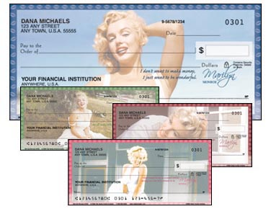
Press Release Summary: Styles Checks builds its Fan Checks line with the addition of a new product suite that features the one and only, Marilyn Monroe. The design includes personal checks, address labels, contact cards, and a checkbook cover that portray classic photos of the vintage model in all her glory.
Press Release Body: Known for its large and eclectic collection of designs, Styles Checks has been offering banking accessories direct to consumers for years. Released as part of its Fan Checks division, the new “Marilyn Monroe” design is a sassy addition to the existing Styles assortment.
On June 26, 2008, Styles Checks launched the new “Marilyn Monroe” product suite via its website, www.styleschecks.com. The personal checks offer four rotating scenes that feature the memorable actress in both innocent and seductive poses. Also on the checks are quotes spoken by Monroe, and all is encompassed by matching borders with small, embedded lipstick marks. As part of the “Marilyn” collection, Styles Checks is also offering matching labels that feature the same portraits as the checks. The personal contact cards offered by Styles Checks allow you to customize your personal contact information against a background of the famous wind-blown Marilyn, while the checkbook cover portrays a more serene actress.
Styles Checks prides itself on being able to appeal to the many interests and hobbies of consumers. With the release of the recent and very feminine “Marilyn Monroe”, new enthusiasts and collectors alike will be able to fall in love with Styles Checks and all the financial products it has to offer.
About Styles Checks:
Whatever interest, hobby, or collection you may have, Styles Checks is sure to have something for you. Including checks that feature musicians, colorful designs, and famous brands, Styles Checks is certain to have something you can fall in love with! Visit our site to make your daily banking routine a little more interesting!

Web Site: http://www.styleschecks.com
Contact Details: 1802 Fashion Court
Joppa, MD 21085

