The Look Presents at Topman


Released on: July 4, 2008, 6:36 am
Press Release Author: Topman
Industry: Apparel & Fashion
Press Release Summary: Topman presents iconic rock fashion for the 21st century
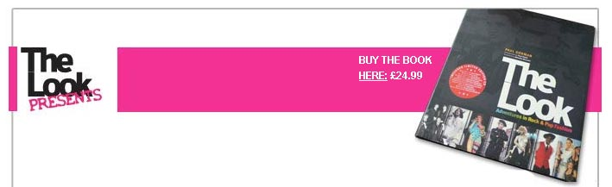
Press Release Body: Spring 08 sees Topman introduce an exciting new label with rock & roll fashion in its DNA: The Look Presents.
Drawing on acclaimed style bible The Look: Adventures in Rock & Pop Fashion, The Look Presents is a creative hub for the legendary designers inspired by the combustion that occurs when great music meets fantastic style.
With three separate collaborative collections produced exclusively for Topman in 08, The Look Presents premieres in stores in May with the animalistic designs of classic 70s label Wonder Workshop, originally worn by such rock icons as Iggy Pop, Sid Vicious, Mick Jagger, Marc Bolan and Led Zeppelin.
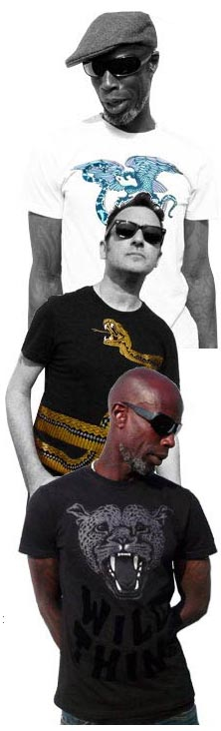
Wonder Workshop designers John Dove and Molly White have reinvented the range for the 21st century, all the while maintaining their original aesthetic.
Available in full colour and monotone, the Wonder Workshop mens tees designs feature tattoo-inspired prints as well as the incredible Wild Thing graphic of a snarling leopard’s head (as worn by Iggy on the cover of the Stooges glam-punk masterpiece Raw Power), a snake which wraps around the torso of the mens tees and prints featuring two hawks and a dove.
The Look Presents is the brainchild of The Look author/music fashion historian Paul Gorman and Soho boutique owner Max Karie. “We are plugging directly into the electricity of rock and pop fashion by working with brilliant original designers,” said Gorman. “The Look Presents is all about reinvigorating the menswear market with authenticity and integrity.”
The Wonder Workshop mens T-shirt will be available from end of May. The collection will be stocked in selected stores and also online at topman.com
The new Wonder Workshop mens T-shirt collection is the first of two t-shirt collaborations between Topman and The Look Presents. The second being The Look Presents Nigel Waymouth, a darkly psychedelic collection of graphic t-shirts from the founder of the legendary King’s Road boutique Granny Takes A Trip. The Granny takes a trip tees are due for release at the end of July.
The third collaborative collection is named Priceless. Designed by Antony Price, this will be his first ever high street ready to wear collection of suits, shirts, trousers and jackets. More details to follow.
About Topman
Topman offers the latest in mens clothing fashion, encompassing a range of styles to suit every shopper. Topman's extensive collection embraces everything from the latest fashion trends to classic pieces, and extends to footwear, accessories and formal wear. Topman also provide the simplest way to search for and buy men's clothing, placing it among the leading fashion retailers in the UK market today.
Web Site: http://www.topman.com/
Contact Details: For further media enquiries, please contact:
Adi Currie
Topman
70 Berners Street
London
W1T 3NL
0207 9271276
www.topman.com

