Australian Health Expert Announces Exciting New Approach to Health for Boomers and Seniors

Released on: August 14, 2008, 3:21 am
Press Release Author: Michael Coleman
Industry: Healthcare
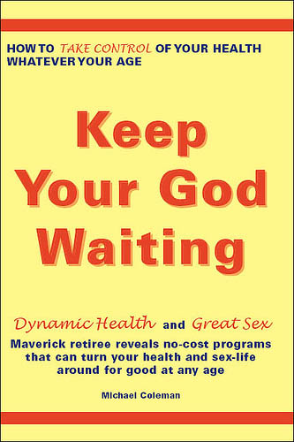
Press Release Summary: Engaging in more sex, natural breathing and other simple strategies could save the 40-plus population millions in health care costs, according to Australian health educator Michael Coleman. His groundbreaking e-book, “Keep Your God Waiting,” promotes a unique approach that anyone can take advantage of with no money, pill popping, strenuous workouts or surgery.
Press Release Body: Melbourne, Australia - - Aug. 14, 2008 – Many countries talk about the feasibility of providing free, universal health care, but Australia-based health educator Michael Coleman has a revolutionary approach for making it happen. And it can work for anyone in any country and at any age.
According to Coleman, more sexual activity and natural breathing are key elements in transforming the health of people over 40. “Preventing the onset of illness by simply doing what comes naturally may provide an effective way to save millions of dollars in health-care costs and cut hospital waiting lists,” Coleman says.
Coleman’s innovative approach is encompassed in an exciting new e-book, “Keep Your God Waiting.” According to the book, anyone—regardless of their age—can have dynamic health, great sex and a super-sharp mind. And the step-by-step techniques revealed in the book are free and easy to use. “There’s nothing to buy, no pills, no endless pounding the pavement, pumping iron or anything like that,” Coleman says.
In his e-book, Coleman shares how simple, no-cost methods can help people:
· Reduce stress
· Build brain-power and improve memory
· Breathe for health and vitality
· Improve their vision
· Boost their immune system
· Achieve their natural weight without dieting
Coleman strongly believes that preventing illness through the use of sex, proper breathing and other natural measures is an effective means for maintaining good health and minimizing health-care costs. However, prevention is not a popular concept with society and modern medicine, he says. ”I know it sounds unbelievable, but people seem to feel more confident and comfortable knowing there’s some sort of ‘cure’ for their illness than about preventing it from occurring in the first place,” he explains. “It’s fair to say society is not particularly interested in prevention. Instead, it’s hooked on treatment – even though it is known that most treatments address symptoms not causes and may lead to the onset of new disease.”
Many people have been conditioned at a subconscious level by health-care marketers, health authorities and their own observations to accept poor health and aging as a normal part of living, Coleman added. “As a consequence, the concept of taking control of one’s health and actually preventing the onset of illness is, for many, very difficult to entertain,” he says.
The disinterest is due, in part, to how prevention has been portrayed, Coleman says. “Prevention has been presented either as gym workouts, jogging and fad diets; as a costly regime of vitamins, hormones, sexual stimulants or; in some instances, as ancient wisdom to which only a fortunate few have access.” Coleman explains. “Faced with those sorts of options, it is hardly surprising people feel little enthusiasm."
Coleman feels that society and medical practitioners should reject the health paradigm that treatment is king. “In its place, we should invest heavily in promoting prevention, so it is seen as an attractive preferred pathway to vibrant health. Presently, developed countries spend on average just three cents in the health dollar on preventive measures” he says.
At 70 years old, Coleman has a wealth of practical experience on the aging process. He holds a degree in pure mathematics and post-graduate qualifications in education and science. He has a diploma in Health, Nutrition and Fitness, an associate degree in Health Education and is a designated nutritional consultant. He also has certificates in Metaphysics and Reiki and is a designated expert on Over-40s health at selfgrowth.com.
Through years of study and personal research, Coleman has become passionate about the power of the body to restore itself and has authored a number of health-related articles and e-books. He has also published material in “Dare to Dream,” which is produced by Living Now, Australia’s premier holistic magazine. “Keep Your God Waiting” is Coleman’s latest effort to educate people on how they can take control of and transform their health, mind and life.
For more information about “Keep Your God Waiting”, please visit http://www.keep-god-waiting.com/ or contact Michael Coleman at +61 3 98034195.
###
Web Site: http://www.keep-god-waiting.com
Contact Details: Media Contact: Michael Coleman, Health Educator and Author
Direct Phone: +61 3 98034195
Direct Email: pr@keep-god-waiting.com

