Gladstone Jewellery Sponsor Main Bar At IJL 2008
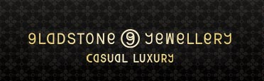
Released on: August 1, 2008, 12:15 pm
Press Release Author: Danny Bluestone
Industry: Apparel & Fashion
Press Release Summary: To celebrate the launch of their luxurious and elegant jewellery showcase at International Jewellery London 2008, Gladstone will be sponsoring the main bar at the show.
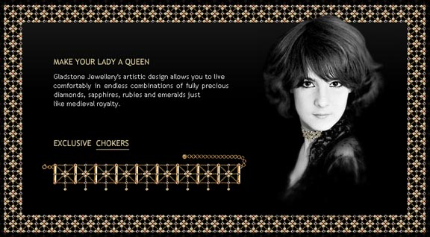
Press Release Body: London, UK, 24/07/08: Taking place between 31st August till 3rd September at Earls Court in London, IJL 2008 is promising to be an event not to be missed for lovers of beautiful and luxury jewellery.
Gladstone have already been tipped to sparkle at the jewellery trade show by several industry insiders, as they showcase their collection of intricate yet lavish jewellery designs, combining fully precious stones such as diamonds, sapphires, rubies and emeralds in rub-over settings linked into a distinctive pattern by a series of delicate white and yellow gold chains.
To celebrate the showcasing of these timeless elegant pieces, Gladstone are set to sponsor the main bar at the show, in the centre of the exhibition hall on 'The Boulevard', with the bar now being named 'The Gladstone Jewellery Bar'. People visiting the bar will be able to enjoy champagne with friends and business contacts in the very heart of the exhibition.
Maria Kunin, Gladstone's senior designer says "We are delighted to announce that we will be sponsoring the 'Gladstone Jewellery Bar' at IJL 2008 where we expect to meet and introduce fine jewellery lovers to our collections of luxurious chokers, rings, earrings, pendants, necklaces and bracelets."
"Our jewellery uses only fully precious stones which we hand-select ensuring that they are of the finest quality. The designs are inspired by a romantic vision of the lavish splendour of Medieval royalty lifestyle, so that the wearer will truly feel like a 'Queen' when wearing a Gladstone piece."
"The result is a unique and distinct collection of what I believe to be classic and sumptuous designs that are lovingly hand-crafted."
Visit Gladstone Jewellery at their luxury jewellery showcase located at stand E330 in the fine jewellery section on 'The Boulevard'.
Alternatively, visit Gladstone Jewellery's online store here: http://www.gladstonejewellery.com to view the products and learn more about the Gladstone brand and their luxury jewellery collection.
Web Site: http://www.gladstonejewellery.com
Contact Details: Gladstone Jewellery
3 Stanhope Mews East,
South Kensington,
London SW7 5QU
Danny Bluestone, Marketing Director
Tel: +44 (0)845 555 7707
Fax: +44 (0) 208 736 0502
Email: bluestone@gladstonejewellery.com
Web: http://www.gladstonejewellery.com

