Sandbox Couture Expand Retail Offering to Global Consumer Audience


Released on: August 29, 2008, 4:18 am
Press Release Author: Sam Brown/Sandbox Couture
Industry: Apparel & Fashion
Press Release Summary: International Shipping Now Available on Select Brands of Baby Clothes & Designer Children's Clothes
Press Release Body: Rancho Santa Margarita – CA August 28, 2008 – Sandbox Couture, a popular online children's boutique retailer of baby clothes, christening gowns and designer baby gifts today announced their expanded retail offering to include order delivery to e-commerce customers worldwide. The new international shipping capability for select designers of couture baby clothes, children's clothes and baby gifts, follows a multi-level expansion strategy initiated by Sandbox Couture last year.
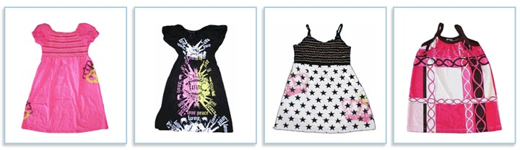
Sandbox Couture is pleased to complete the groundwork for another phase of their business development and growth plan. The online retailer has systematically implemented new levels of key product categories and expanded the core offerings to a wider, global audience. Beginning in early 2007, the online boutique retailer first expanded its retail offering to Canada, followed by the launch of its Amazon Marketplace storefront in the Fall of 2007. The international shipping capability further differentiates Sandbox Couture from other online retailers and fulfills a long standing initiative spurred by consumer demand.
SandboxCouture.com, which has been selling baby clothes and designer children's clothes since 2005, has grown from a one-tier online retailer, to a fully integrated, multi-channel ecommerce merchant. Over the next few months, Sandbox Couture will continue to identify target markets both in geographic terms as well as product offerings.
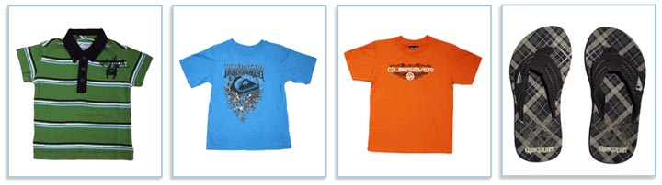
"The international shipping integration is just one aspect of the company's overall expansion strategy," stated Sam Brown, spokesperson for Sandbox Couture. "Over the past year, Sandbox Couture has expanded their product lines and secured new supplier relationships, thereby widening their product categories as well as its service areas, bringing unique children's accessories, designer children's clothes, couture baby clothes and action sports apparel to customers worldwide. While the company will restrict the sales of certain brands to availability only in the U.S., based on supplier agreements, the majority of brands will be available," Brown concluded
By widening its retail reach, Sandbox Couture is able to further extend it's brand awareness and couture following, but also provides the e-tailer the ability to leverage higher levels of inventory for top brands in baby clothes and designer children's clothes. In addition to purchasing items directly, customers can buy gift certificates giving the gift of style and selection to friends and family worldwide. For more information on specific countries including in the new shipping policy, please visit http://www.sandboxcouture.com To begin shopping for designer baby clothes, children's clothes, christening gowns or unique baby gifts, please visit http://www.SandboxCouture.com.
About Sandbox Couture
Sandbox Couture is an online children's boutique retailer, providing designer baby clothes, designer children's clothing and unique baby gifts. The company takes pride in hand selecting products from top designers, thereby ensuring quality and contemporary style. Sandbox Couture’s philanthropic contributions and socially conscious business practices are at the forefront of the company’s ideals and corporate culture. Founded in 2005, Sandbox Couture is privately held and headquartered in Rancho Santa Margarita, CA. For information about Sandbox Couture, please visit the company's web site at http://www.SandboxCouture.com
#
Web Site: http://www.sandboxcouture.com
Contact Details: Press Contact
Sam Brown
949-459-2505
pr@sandboxcouture.com
92688

